PRACTICE IN BIOINFORMATICS (15 CREDITS)
Pancreatic adenocarcinoma
Table of Contents

PIP5K1A association with DFS in classical and basal-like subtypes of Pancreatic Adenocarcinoma 2
PIP5K1A association with OS in classical and basal-like subtypes of Pancreatic Adenocarcinoma 6
PIP5K1A association with DFS in classical and basal-like subtypes with KRAS mutation of Pancreatic Adenocarcinoma 10
PIP5K1A association with OS in classical-like and basal-like subtypes with KRAS mutation of Pancreatic Adenocarcinoma 12
Theme correction: PIP5K1A association with DFS in classical-like and basal-like subtypes of Pancreatic Adenocarcinoma 14
PIP5K1A correlation with immune infiltrates in pancreatic adenocarcinoma (TCGA-PAAD) 15
Progression Free Survival (PFS) study of PIP5KIA based on various parameters in PAAD 25

PIP5K1A association with DFS in classical and basal-like subtypes of Pancreatic Adenocarcinoma

The analysis was carried out locally on R using the survival and survminer packages on TCGA_PAAD dataset. Out of the 182 samples, 150 contained data on the classification based on classical-like and basal-like subtypes of cancer.
Basal-like subtype | 65 samples
Classical-like subtypes | 85 samples

The PIP5K1A expression was divided into low and high expression categories using the median expression level as the cutoff value. DFS data was imported into R from cBioPortal suing the clinical data file since the original TCGA pan dataset did not contain the necessary DFS columns. The KM survival curves for High and Low expression groups within the two isolated subtypes were computed and plotted, followed by Mantel-Cox log-rank test to determine statistical significance. Going Beyonce visual metrics, univariate cox regression was done to calculate risk and control for clinical variables. The Hazard Ratio (HR) and its 95% CI for PIP5K1A was also computed. Finally, for validation testing, Cox model was run on the entire TCGA-PAAD cohort without the categorization into subtypes. The resulting plots and statistics are attached below.
1.1.1 DFS analysis for PIP5K1A in Basal-like subtype
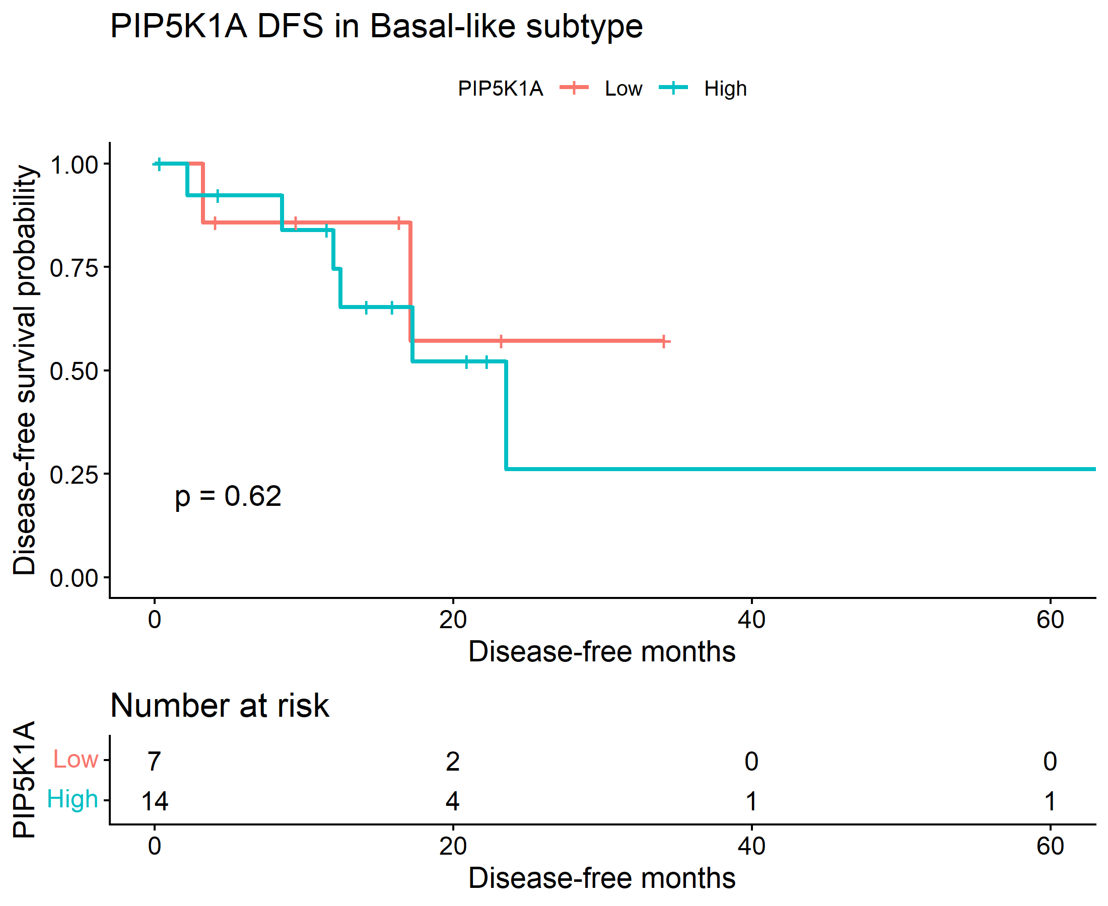
The basal-like KM curve shows separation between low and high PIP5K1A groups, but the log-rank p-value is 0.62, so that difference is not statistically significant. The Cox (results shown below) model also is not significant: HR 1.50 with a wide 95% CI and p = 0.62. So, in basal-like tumors, there is no significant evidence that PIP5K1A expression predicts DFS.
1.1.2 DFS analysis for PIP5K1A in classical-like subtype
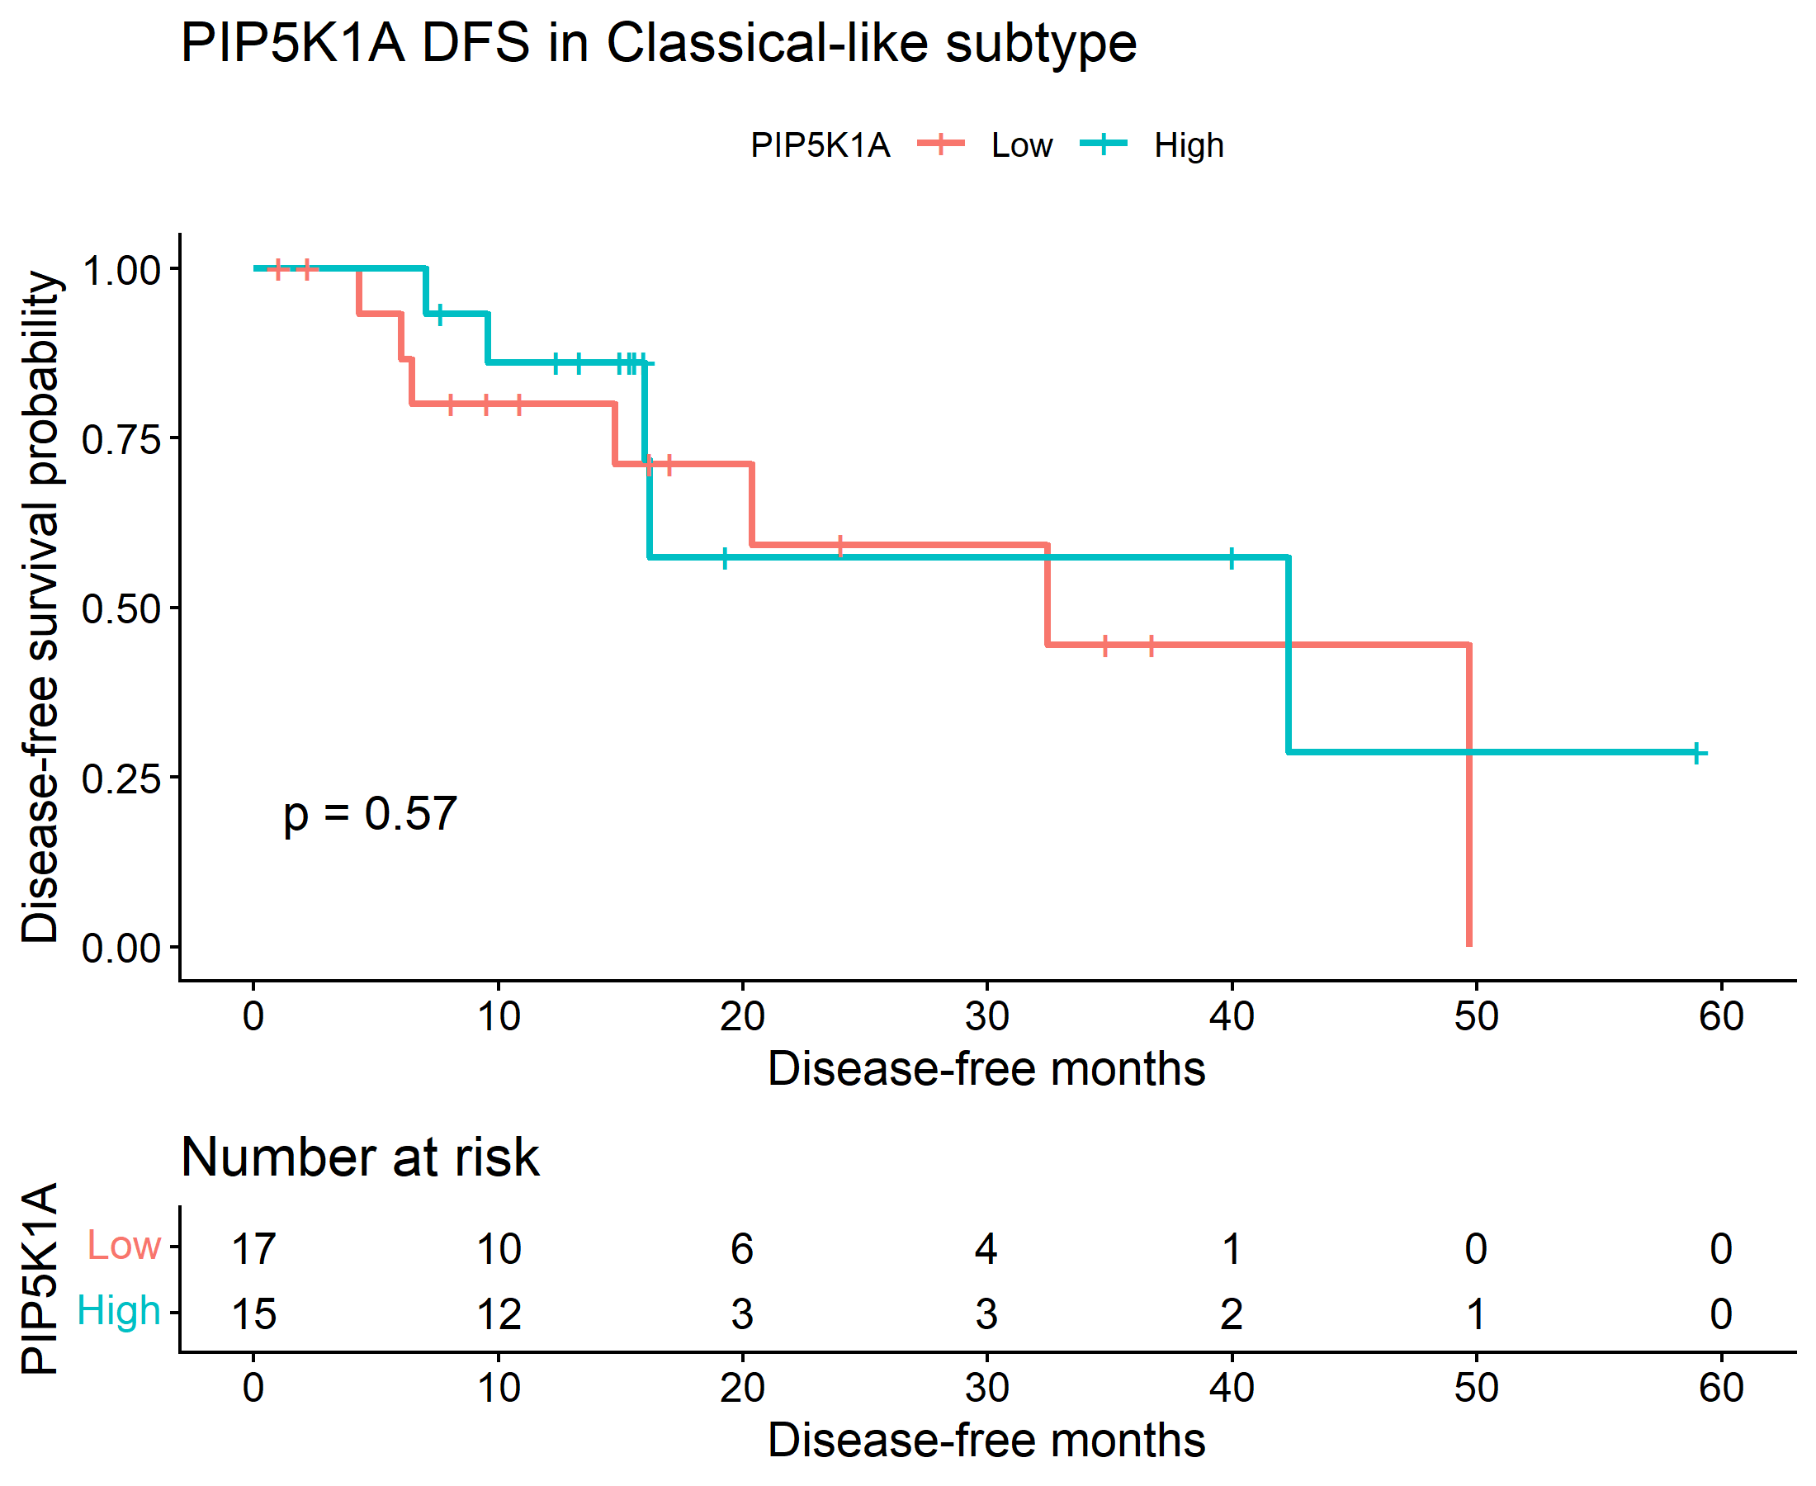
The classical-like KM plot also shows no convincing separation, with log-rank p = 0.57. The Cox model similarly is not significant: HR 0.71 with p = 0.57. This implies that PIP5K1A is not associated with DFS in the classical-like subgroup either.
1.1.3. Log-rank test results DFS

Subtype | Chisq | P Value
Basal-like | 0.250458 | 0.616753
Classical-like | 0.325049 | 0.568589

The log-rank table shows non-significant chi-square values for both subtypes: 0.250458 for basal-like and 0.325049 for classical-like. The corresponding p-values, 0.616753 and 0.568589, are both far above 0.05. So, the survival curves are not different enough to reject the null hypothesis.
1.1.4. Cox Proportional Hazards Regression Results DFS

Subtype | Hr | Lower_95_Ci | Upper_95_Ci | P Value
Basal-like | 1.501526 | 0.302301 | 7.458057 | 0.619148
Classical-like | 0.713976 | 0.223093 | 2.284976 | 0.570274

The Cox results agree with the KM analysis: basal-like HR 1.50, classical-like HR 0.71, and both p-values are non-significant. The confidence intervals are wide and include 1, which means the effect could easily be null.m This suggests limited precision, likely because the DFS sample sizes are small
1.1.5 Interaction and Validation testing results DFS

Term | Coefficient | HR | Lower_95 | Upper_95 | P value | significance
PIP5K1A_z | 0.2612 | 1.2985 | 0.5620 | 3.000 | 0.54095 | NS
Subtype Classical-like | -0.0433 | 0.9576 | 0.3601 | 2.5467 | 0.93080 | NS
PIP5K1A z:subtype Classical-like | -0.1120 | 0.8940 | 0.2951 | 2.7083 | 0.84294 | NS

Cox interaction analysis did not show a significant interaction between PIP5K1A expression and Moffitt subtype, indicating no evidence that the prognostic effect of PIP5K1A on DFS differs between basal-like and classical-like tumors.
Important: All confidence intervals are wide and include 1, so the estimates are imprecise, which usually means limited sample size and/or limited event numbers for the DFS endpoint (from AI).
Next. to choose the cutoff, I calculated the maximum observed follow-up time in each expression group (PIP5K1A high and low), then chooses the smaller of those two.
1.1.1.2 DFS analysis for PIP5K1A in Basal-like subtype (with high follow-up months cut off)
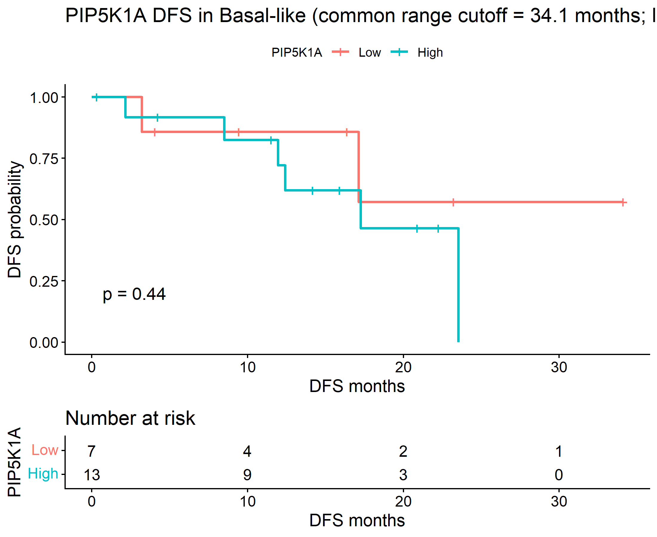
1.1.1.2 DFS analysis for PIP5K1A in classical-like subtype (with high follow-up months cut off)
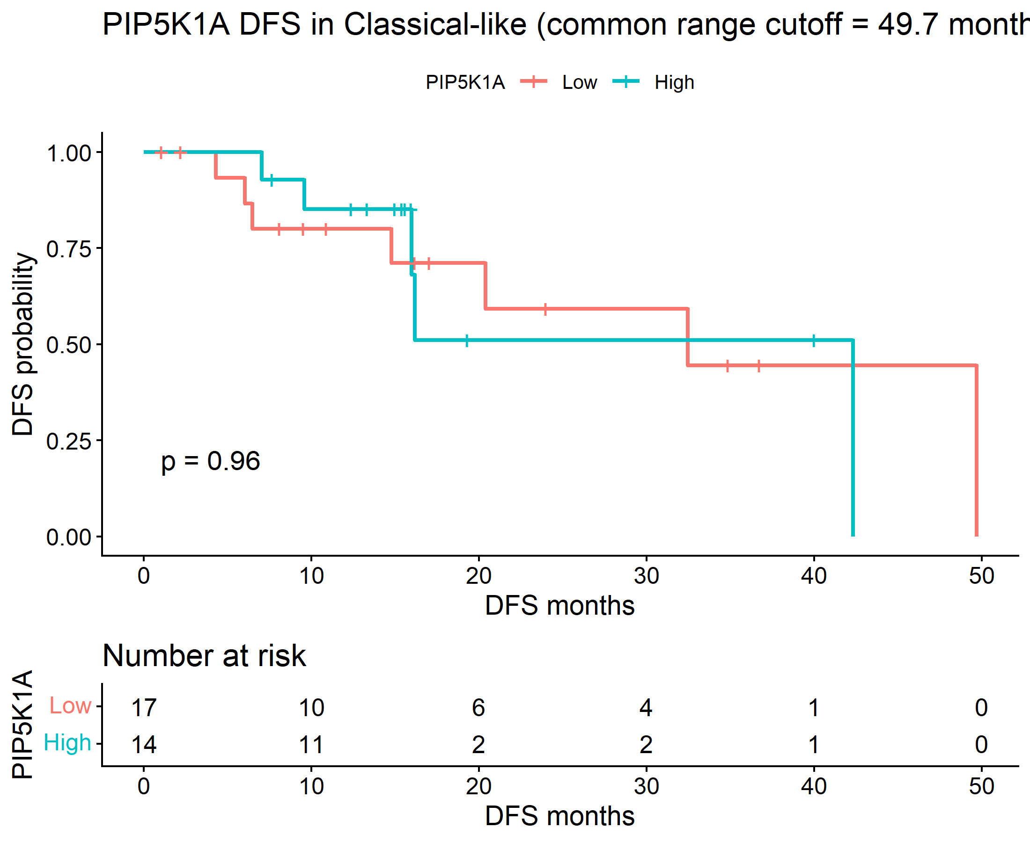

1.1.4. Cox Proportional Hazards Regression Results DFS (With high follow-up months cut off)
subtype | HR | lower_95_CI | upper_95_CI | P value
Basal-like | 1.861603 | 0.372508 | 9.303341 | 0.449038
Classical-like | 1.032183 | 0.308289 | 3.45585 | 0.959025

1.1.5 Interaction and Validation testing results DFS (With high follow-up months cut off)

term | Coef | HR | lower_95_CI | upper_95_CI | P value | signif
PIP5K1A_z | 0.332261 | 1.394117 | 0.64264 | 3.024342 | 0.400404 | ns
subtypeClassical-like | -0.25081 | 0.778172 | 0.285166 | 2.123504 | 0.624363 | ns
PIP5K1A  z:subtypeClassical-like | -0.18107 | 0.834376 | 0.28777 | 2.419237 | 0.738846 | ns

PIP5K1A association with OS in classical and basal-like subtypes of Pancreatic Adenocarcinoma

2.2.1 OS analysis for PIP5K1A in Basal-like subtype

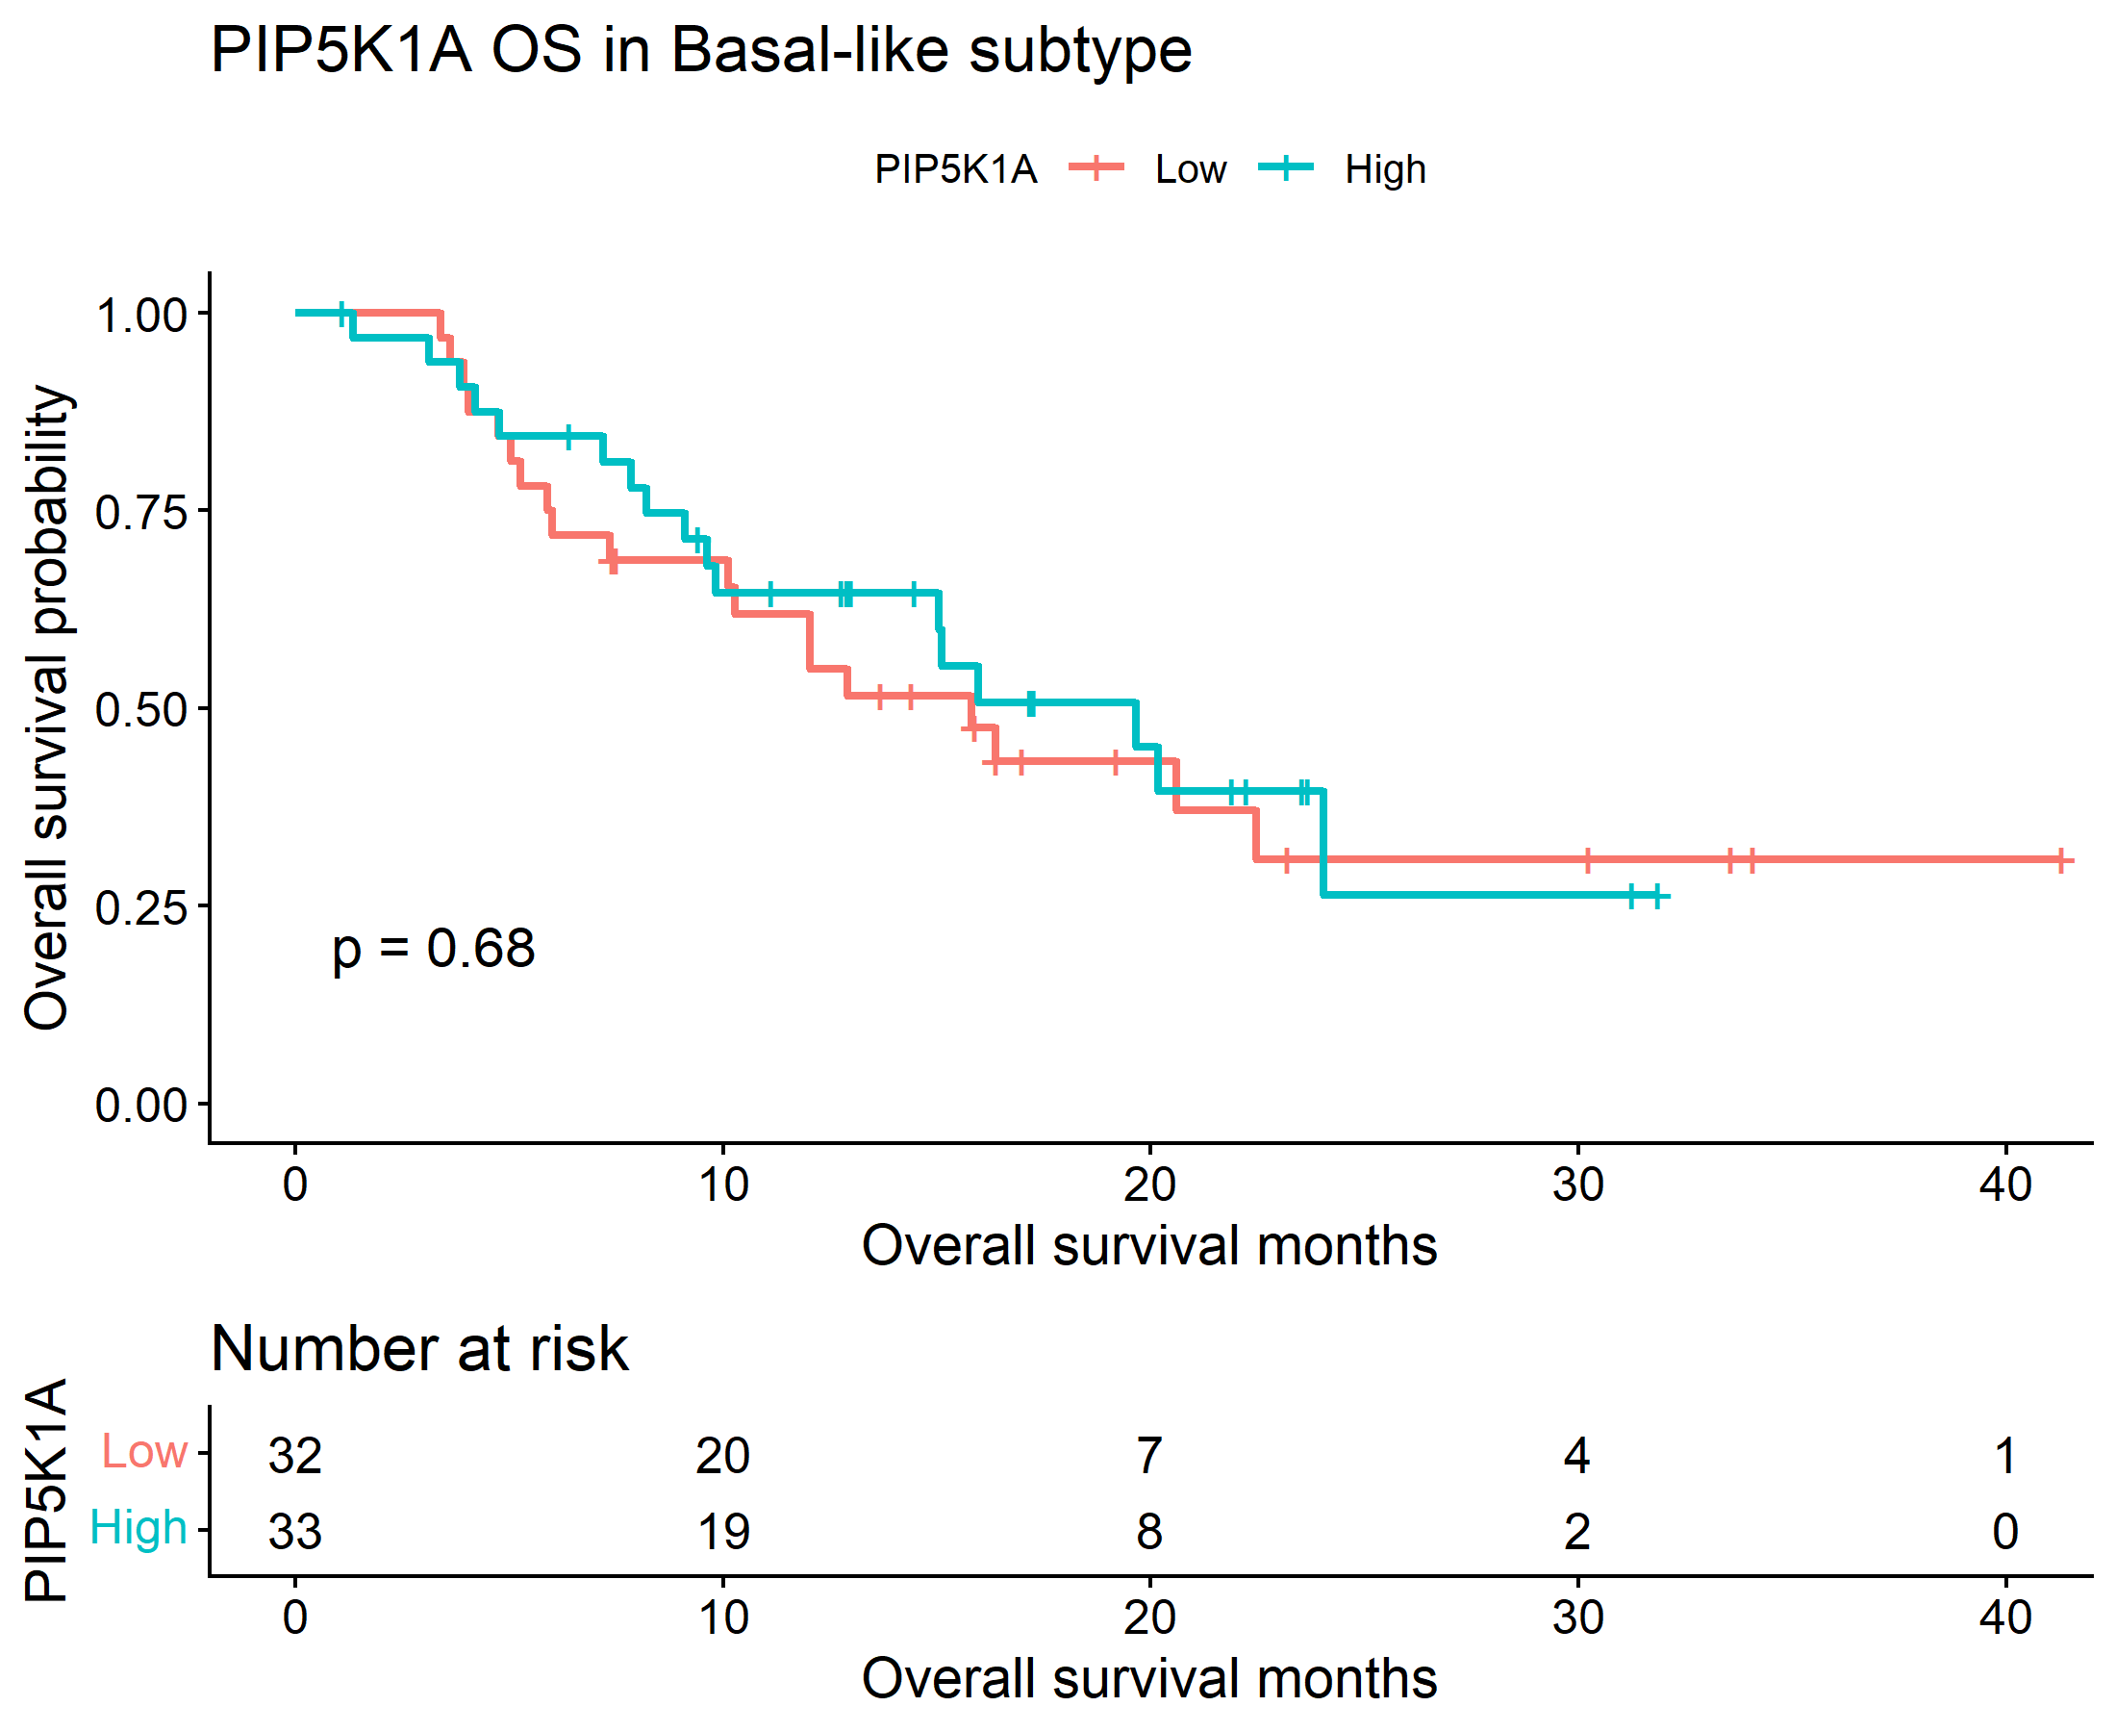
1.2.2 OS analysis for PIP5K1A in classical-like subtype

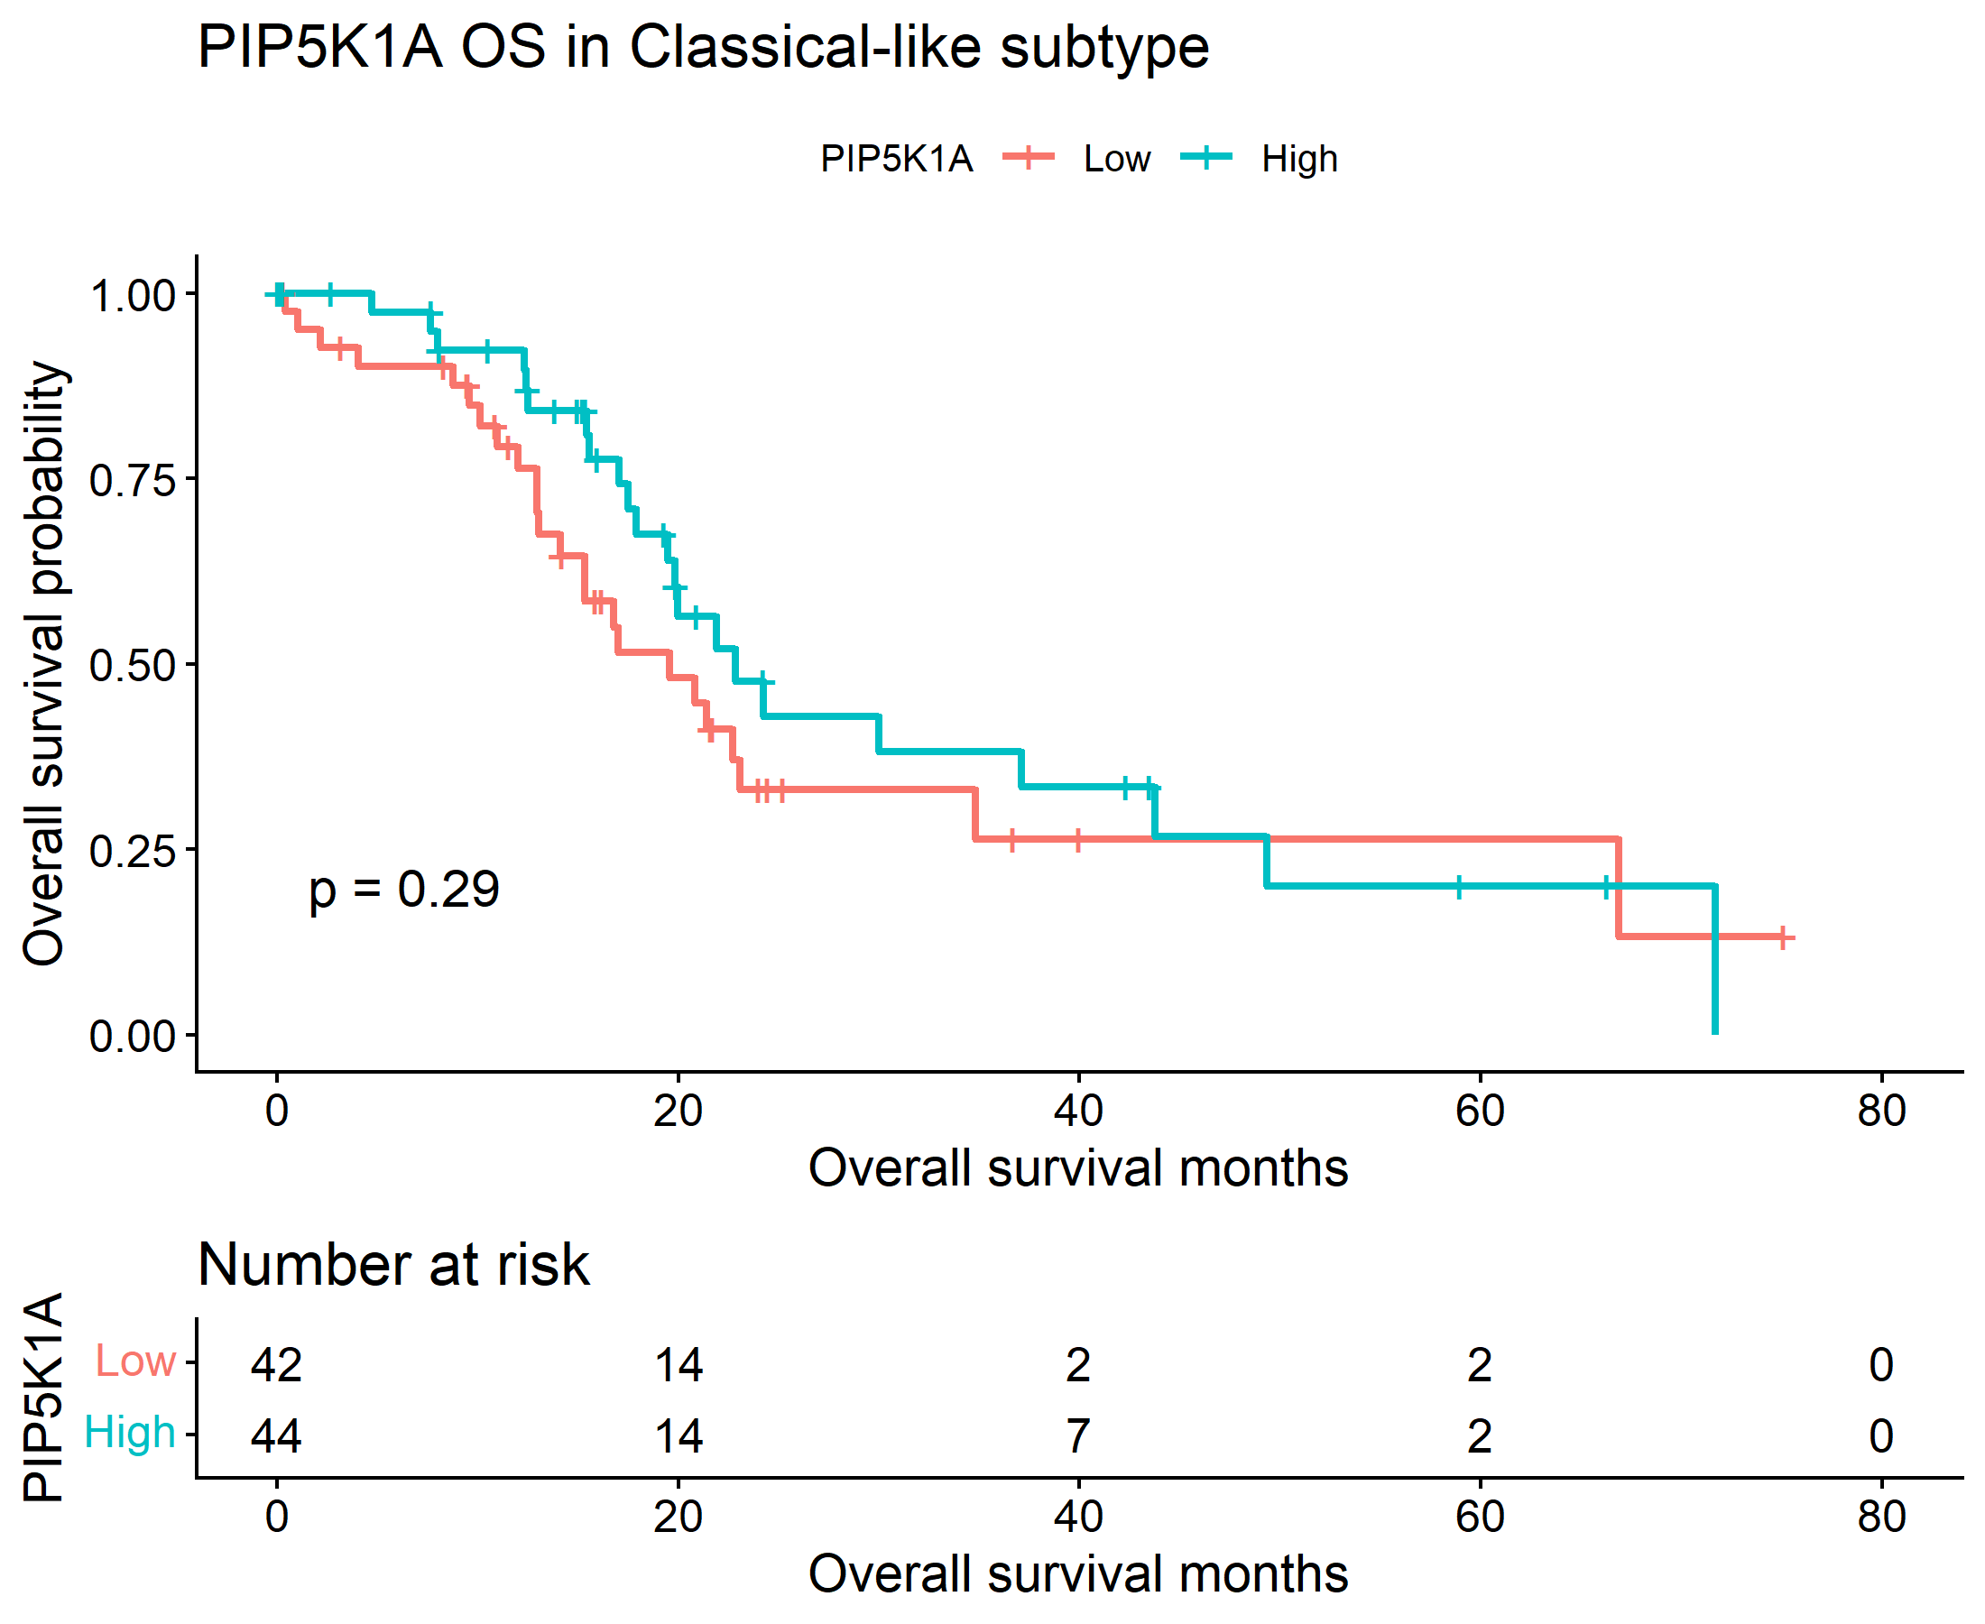

1.2.3 Log-rank test results OS
Subtype | Chisq | P Value
Basal-like | 0.166379 | 0.68335
Classical-like | 1.110344 | 0.292007

PIP5K1A was not significantly associated with overall survival in either basal-like or classical-like TCGA-PAAD subtypes, and the Kaplan–Meier curves showed no clear separation between high- and low-expression groups. The log-rank tests were non-significant in both subtypes.

1.2.4. Cox Proportional Hazards Regression Results OS

Subtype | Hr | Lower_95_CI | Upper_95_CI | P Value
Basal-like | 0.871342 | 0.452552 | 1.677677 | 0.680324
Classical-like | 0.731329 | 0.408296 | 1.309939 | 0.29274

The Cox models developed also showed non-significant hazard ratios with confidence intervals crossing 1.

1.2.5. Interaction and Validation testing results OS

Term | Coefficient | HR | Lower_95 | Upper_95 | P value | significance
PIP5K1A_z | 0.0993 | 1.1044 | 0.7710 | 1.58178 | 0.5881 | NS
Subtype Classical-like | -0.40714 | 0.6655 | 0.4188 | 1.05776 | 0.0850 | NS
PIP5K1A z:subtype Classical-like | -0.20182 | 0.8172 | 0.5146 | 1.2979 | 0.3925 | NS

There was also no evidence of an expression-by-subtype interaction for OS, indicating that the prognostic effect of PIP5K1A did not differ between basal-like and classical-like tumours.

2.2.1 OS analysis for PIP5K1A in Basal-like subtype (with high follow-up months cut off)
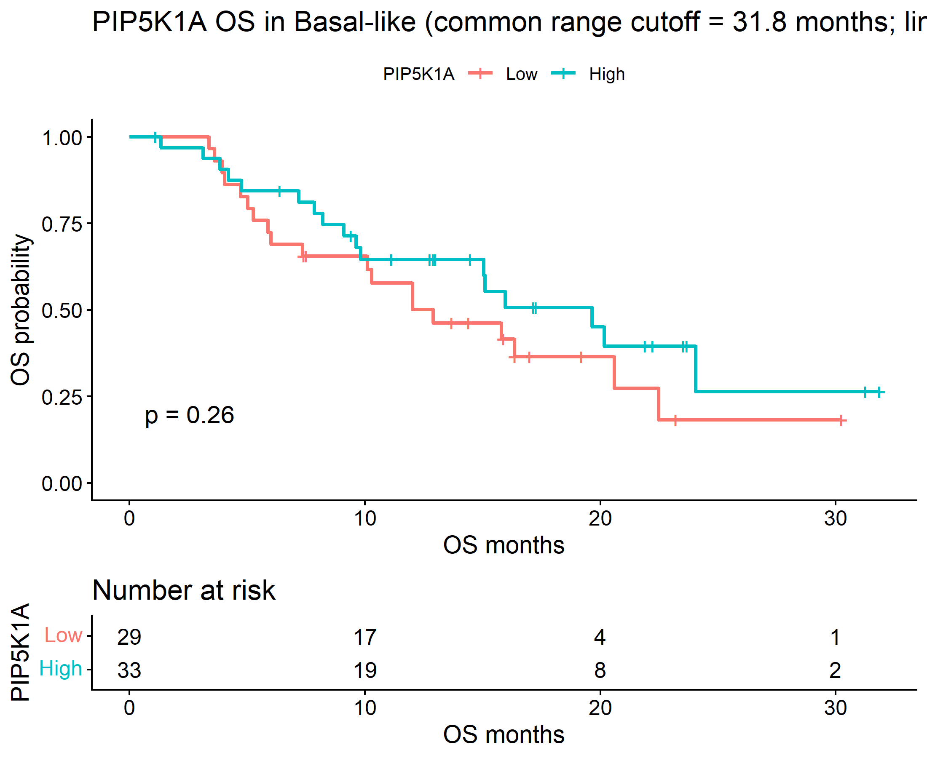

1.1.1.2 OS analysis for PIP5K1A in classical-like subtype (with high follow-up months cut off)
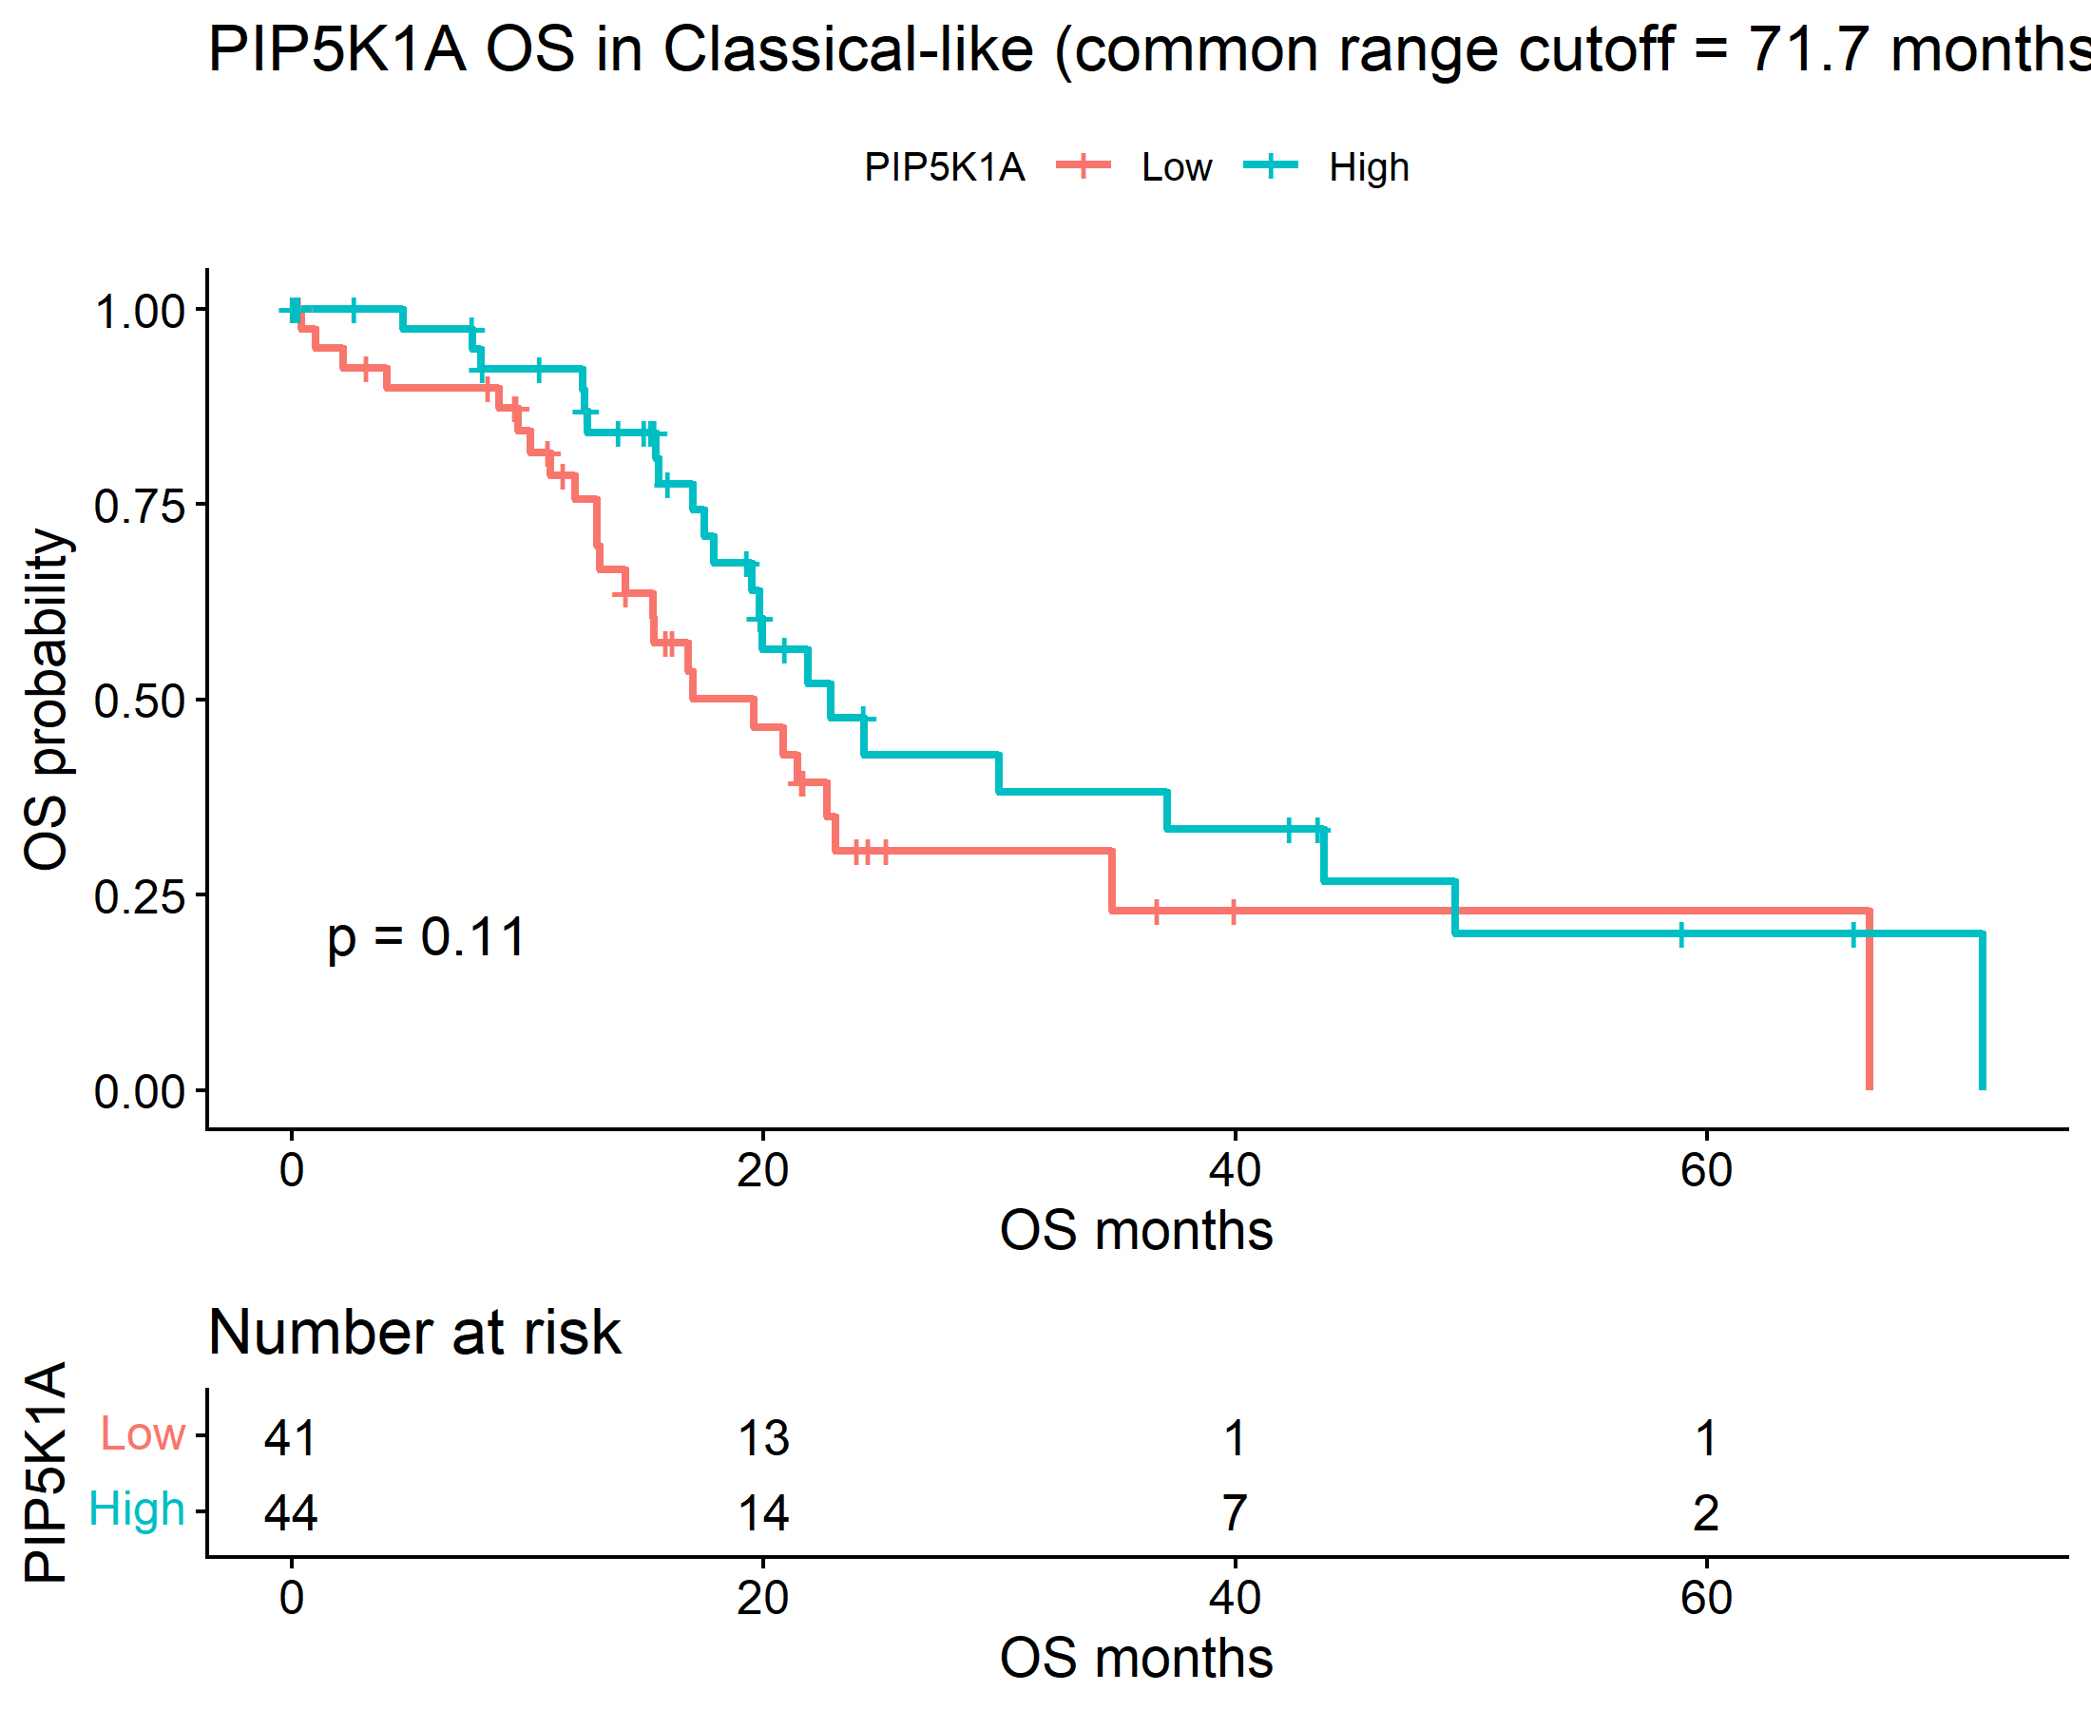
1.2.4. Cox Proportional Hazards Regression Results OS (With high follow up months cut off)
subtype | HR | lower_95_CI | upper_95_CI | P value
Basal-like | 0.683698 | 0.353991 | 1.320496 | 0.257558
Classical-like | 0.622271 | 0.343703 | 1.126615 | 0.117272

1.2.5. Interaction and Validation testing results OS (with high follow up months cut off)
Term | Coef | Hr | Lower_95_Ci | Upper_95_Ci | P Value | Signif
PIP5K1A_z | 0.03066 | 1.031135 | 0.723853 | 1.468861 | 0.86514 | ns
subtypeClassical-like | -0.55998 | 0.571222 | 0.357487 | 0.912746 | 0.019193 | *
PIP5K1A_  z:subtypeClassical-like | -0.1726 | 0.841474 | 0.533479 | 1.327287 | 0.457911 | ns

PIP5K1A association with DFS in classical and basal-like subtypes with KRAS mutation of Pancreatic Adenocarcinoma

In the TCGA-PAAD cohort, out of the 150 samples that contained data on the classification based on classical-like and basal-like subtypes, 140 samples showed KRAS mutations while 10 did not. They were categorized into basal-like (n=63) and classical-like (n=77) subtypes as below. Similar to how DFS and OS analyses were done previously, the data was computed specifically for samples that showed KRAS mutations.
2.1.1 DFS analysis for PIP5K1A in KRAS-mutant Basal-like subtype
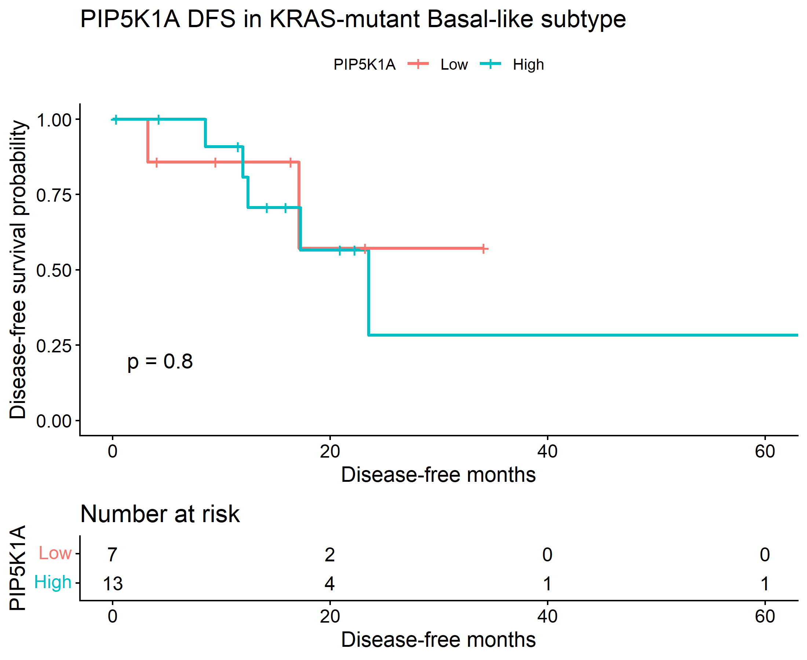
2.1.2 DFS analysis for PIP5K1A in KRAS-mutant classical-like subtype
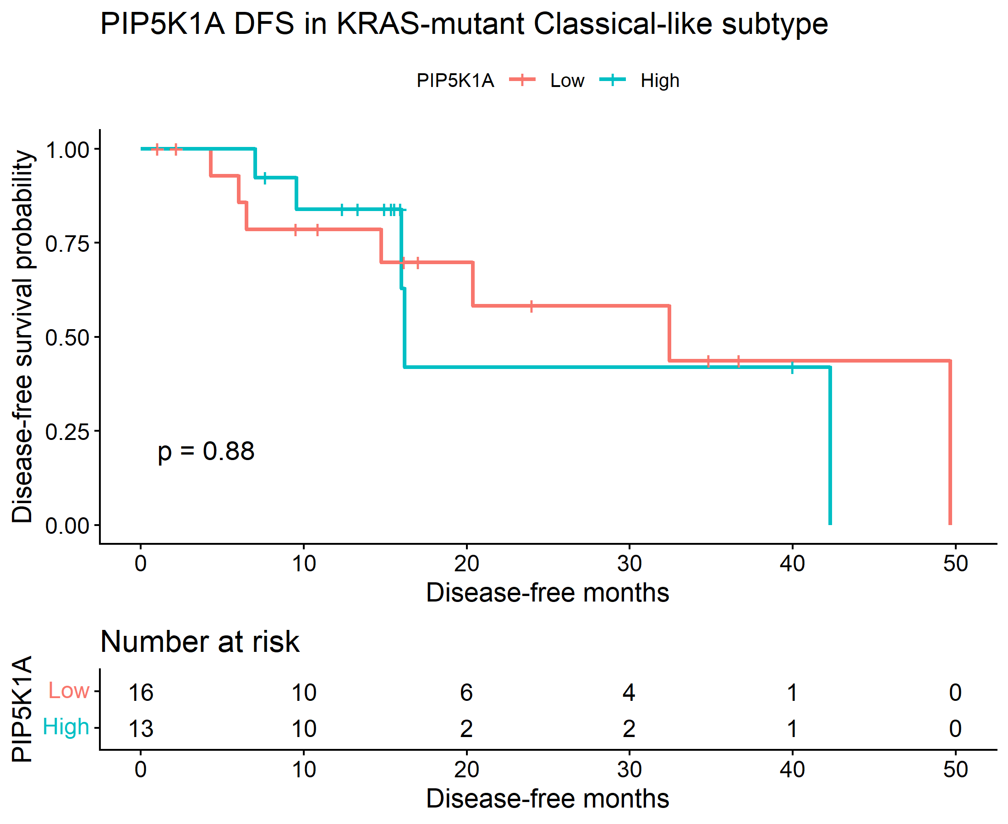
2.1.3 Log-rank test results DFS KRAS
Subtype | Chisq | P Value
Basal-like | 0.064694 | 0.799225
Classical-like | 0.023343 | 0.878569

2.1.4. Cox Proportional Hazards Regression Results DFS KRAS
Subtype | Hr | Lower_95_Ci | Upper_95_Ci | P Value
Basal-like | 1.237145 | 0.239286 | 6.396221 | 0.799591
Classical-like | 1.09911 | 0.32687 | 3.695787 | 0.878609

2.1.5. Interaction and Validation testing results DFS KRAS
Term | coefficient | Hr | Lower_95_Ci | Upper_95_Ci | P Value | Signif
PIP5K1A_z | 0.112565 | 1.119145 | 0.446558 | 2.804753 | 0.810226 | ns
subtypeClassical-like | 0.198596 | 1.219689 | 0.452442 | 3.288026 | 0.694687 | ns
PIP5K1A_z:subtypeClassical-like | 0.014576 | 1.014683 | 0.319943 | 3.21801 | 0.980253 | ns

DFS did not differ significantly between PIP5K1A high and low groups in either basal-like or classical-like tumors. The log-rank p-values were 0.799 in basal-like and 0.879 in classical-like, and the Cox models were also non-significant, with wide confidence intervals crossing 1. The interaction test was not significant either, showing no evidence that the effect of PIP5K1A on DFS differed by subtype.
2.1.1 DFS analysis for PIP5K1A in KRAS-mutant Basal-like subtype (With high Follow-up months cut off)

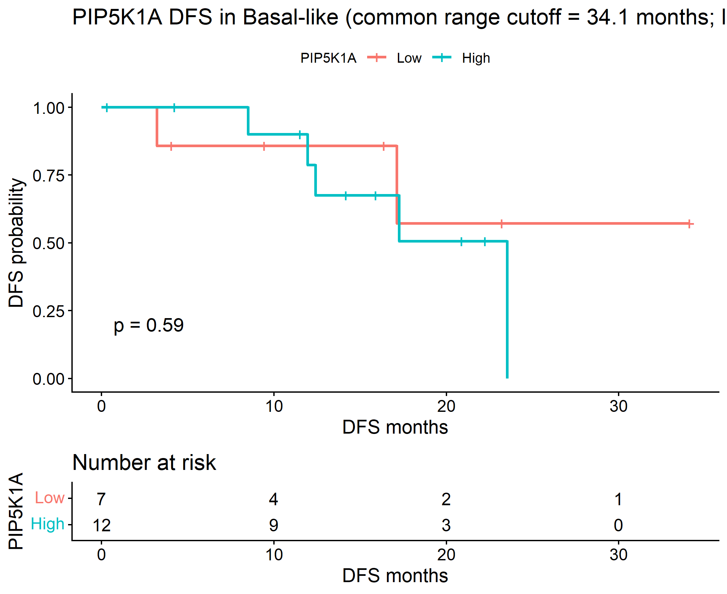

PIP5K1A association with OS in classical-like and basal-like subtypes with KRAS mutation of Pancreatic Adenocarcinoma

2.2.1. OS analysis for PIP5K1A in KRAS-mutant Basal-like subtype
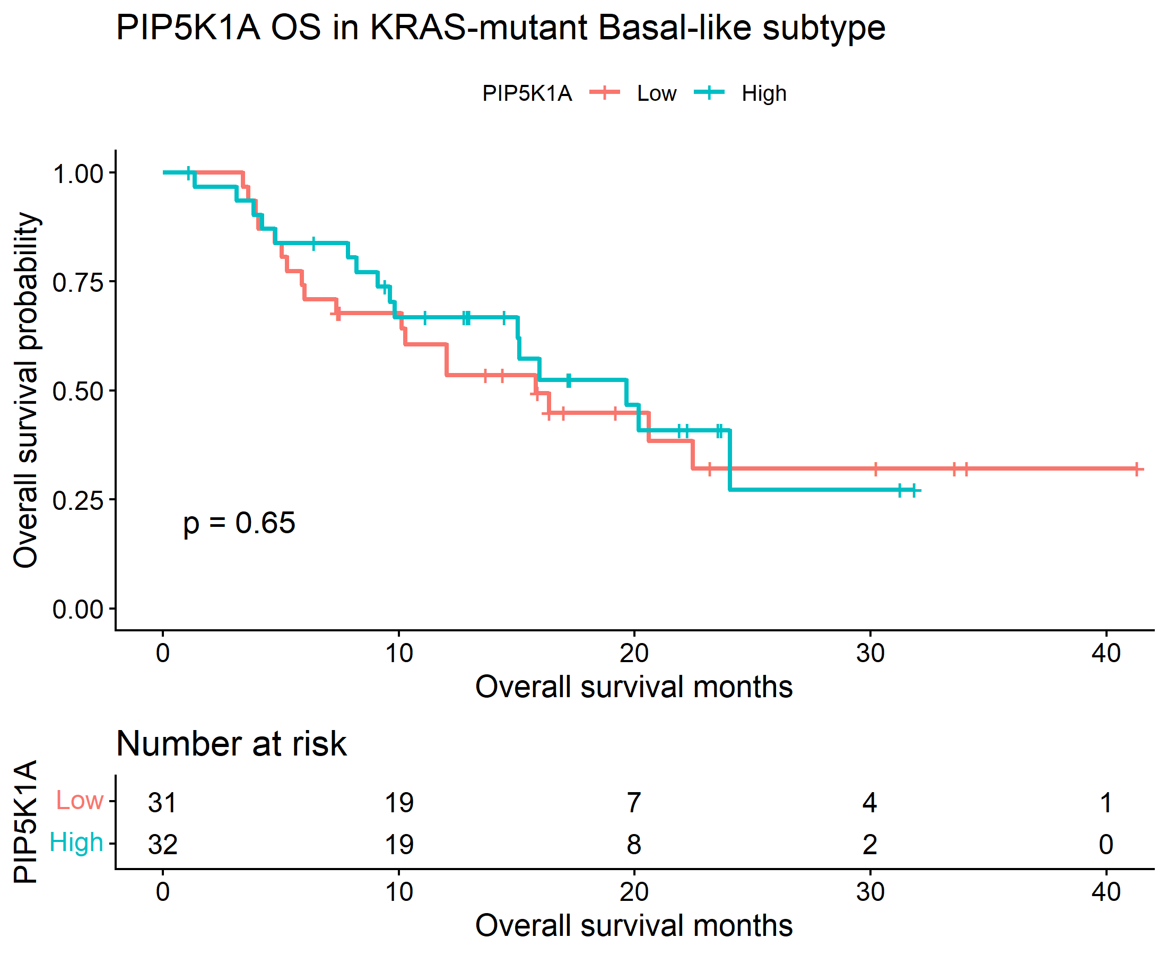
2.2.2. OS analysis for PIP5K1A in KRAS-mutant classical-like subtype

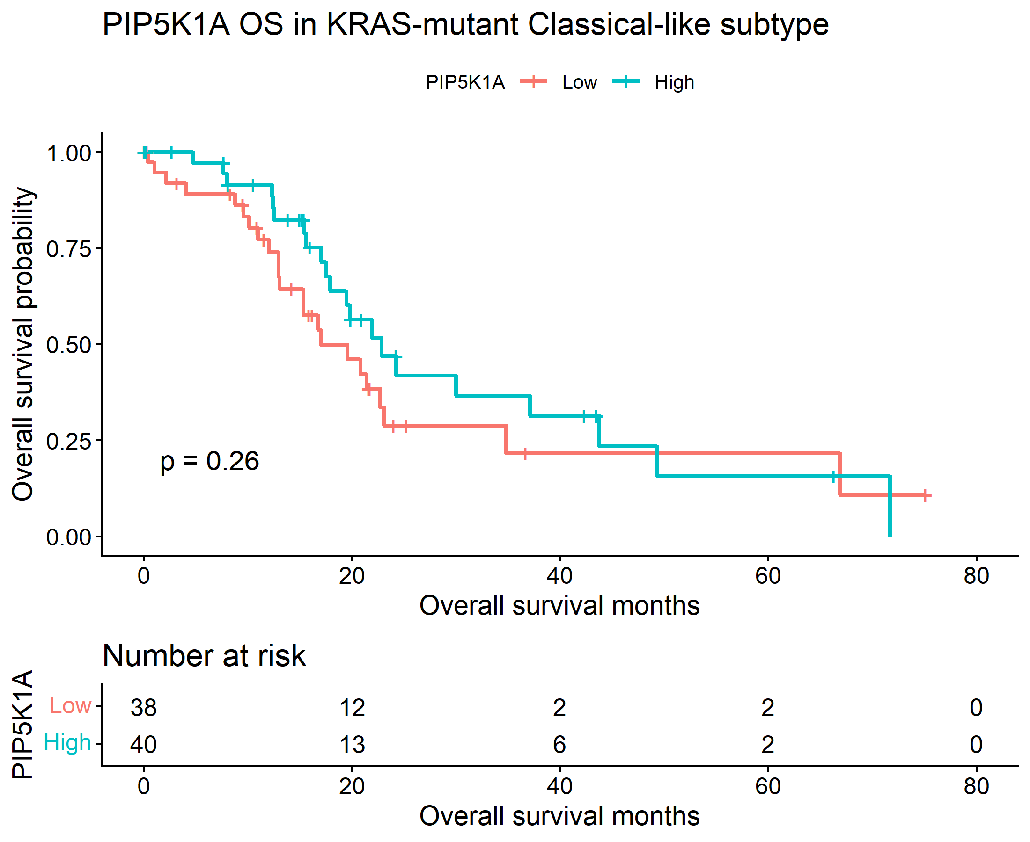
2.2.3 Log-rank test Results OS KRAS
Subtype | Chisq | P Value
Basal-like | 0.20659 | 0.649453
Classical-like | 1.275625 | 0.258714

2.2.4 Cox Proportional Hazards Regression Results OS KRAS
Subtype | Hr | Lower_95_Ci | Upper_95_Ci | P Value
Basal-like | 0.853935 | 0.435032 | 1.676211 | 0.646328
Classical-like | 0.709606 | 0.390779 | 1.288558 | 0.259727

2.2.5. Interaction and Validation testing results OS KRAS
Term | Coefficient | Hr | Lower_95_Ci | Upper_95_Ci | P Value | Signif
PIP5K1A_z | 0.090656 | 1.094893 | 0.757507 | 1.582548 | 0.629566 | ns
subtypeClassical-like | -0.30448 | 0.737508 | 0.458982 | 1.185055 | 0.208287 | ns
PIP5K1A_z:subtypeClassical-like | -0.26718 | 0.765537 | 0.476774 | 1.229191 | 0.26879 | ns

The OS results show the same pattern: no significant association between PIP5K1A expression and survival in either subtype. The log-rank p-values were 0.649 for basal-like and 0.259 for classical-like, while the Cox models again had confidence intervals crossing 1. The interaction term was also non-significant, so there is no evidence of subtype-specific prognostic behavior for PIP5K1A in the KRAS-mutant cohort.
2.2.1. OS analysis for PIP5K1A in KRAS-mutant Basal-like subtype (With High Follow up months cut off)
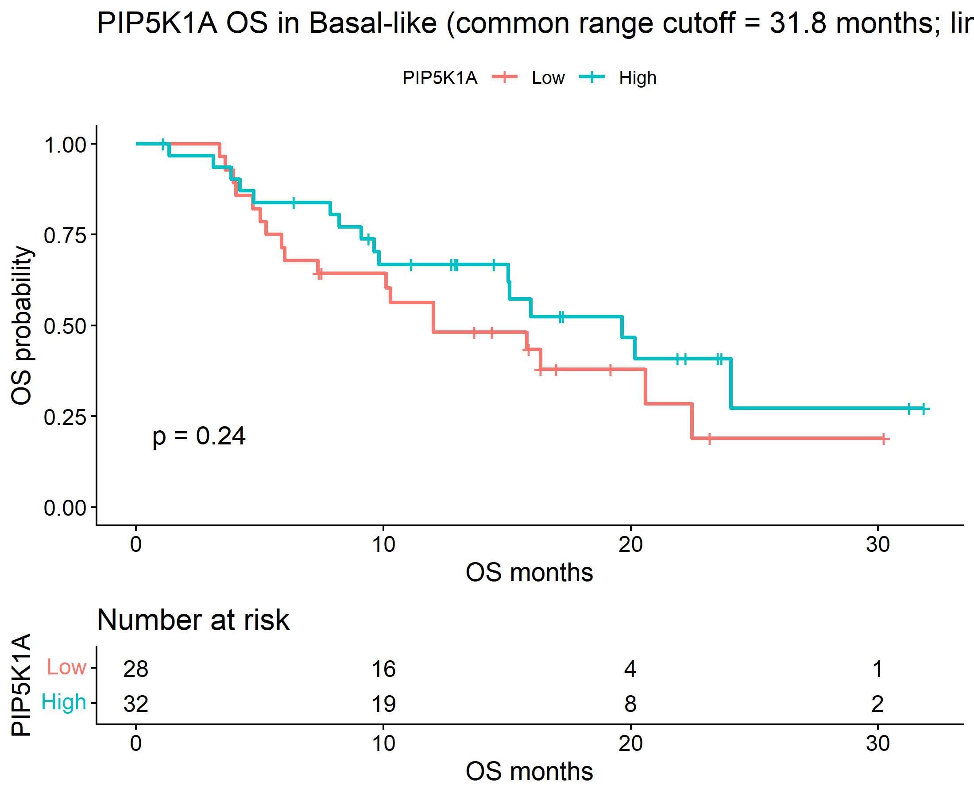

Theme correction: PIP5K1A association with DFS in classical-like and basal-like subtypes of Pancreatic Adenocarcinoma

The final theme corrected KM plots for PIP5K1A association with classical and basal-like subtypes in TCGA-PAAD
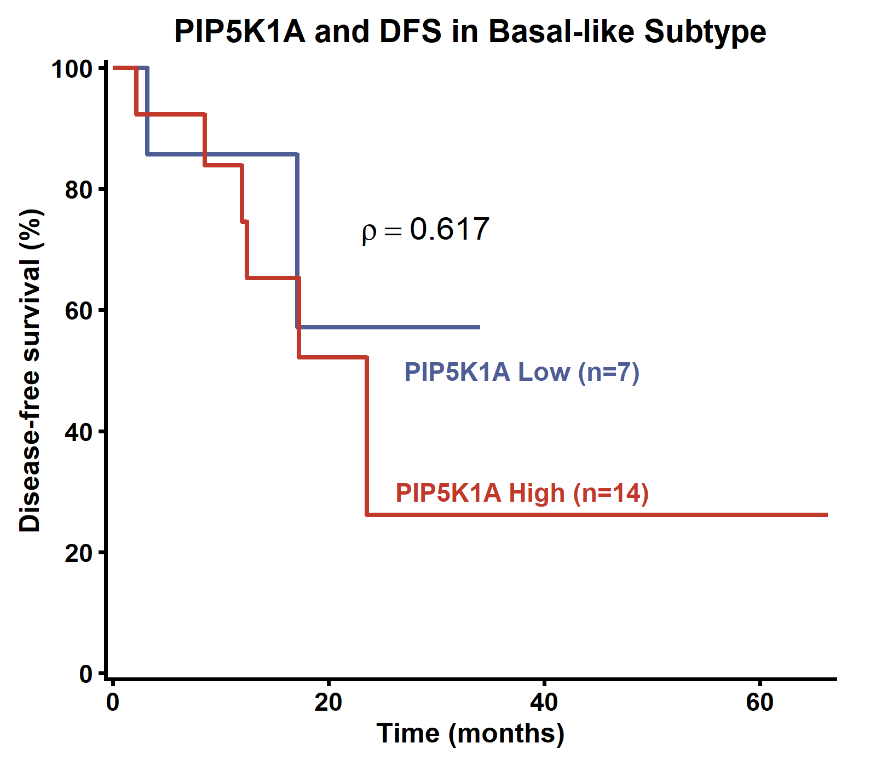

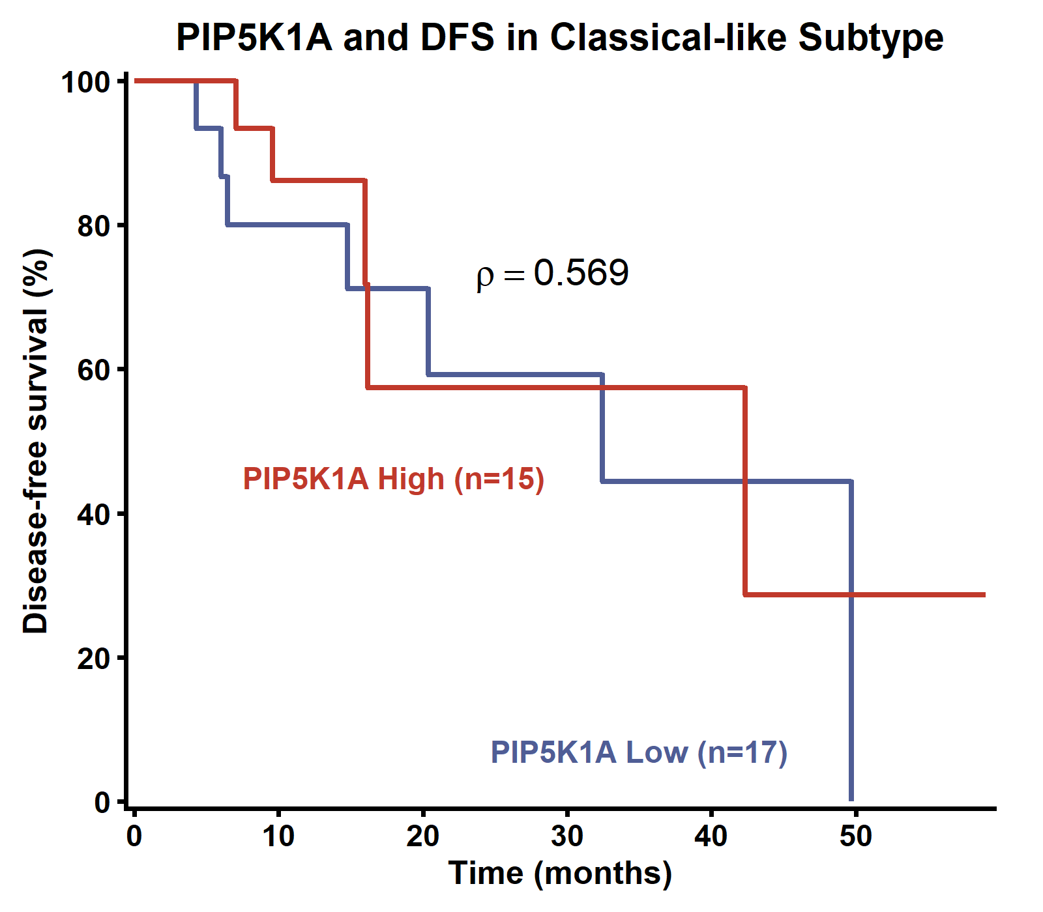

PIP5K1A correlation with immune infiltrates in pancreatic adenocarcinoma (TCGA-PAAD)

The correlation analysis was done on TIMER3 webtool by compbio. The results obtained matched the previous results exactly, validating the analysis. A table summarising the statistics can be seen below, followed by individual correlation plots for each category. Correlations that were statistically significant are highlighted (red-positive correlation, blue-negative correlation).
 | Purity |  | Infiltration level
 | Rho | P value | Rho | P value
Tumor purity | 0.038 | 0.6 | -0.069 | 0.3
Stroma score | 0.038 | 0.6 | 0.148 | 0.05
Immune score | 0.038 | 0.6 | -0.016 | 0.8
Cancer associated fibroblast | 0.038 | 0.6 | 0.332 | 0.000009
Common myeloid progenitors | 0.038 | 0.6 | -0.08 | 0.3
Endothelial cells | 0.038 | 0.6 | 0.154 | 0.04
Tumor CD274 | 0.038 | 0.6 | 0.466 | 0.1
Myeloid-derived suppressor cells | 0.038 | 0.6 | 0.366 | 0.0000009
Interferon gamma | 0.038 | 0.6 | 0.198 | 0.009
Common lymphoid progenitors | 0.038 | 0.6 | 0.277 | 0.0002
NK cells activated | 0.038 | 0.6 | -0.254 | 0.0008

- Correlation with tumour purity (not significant)
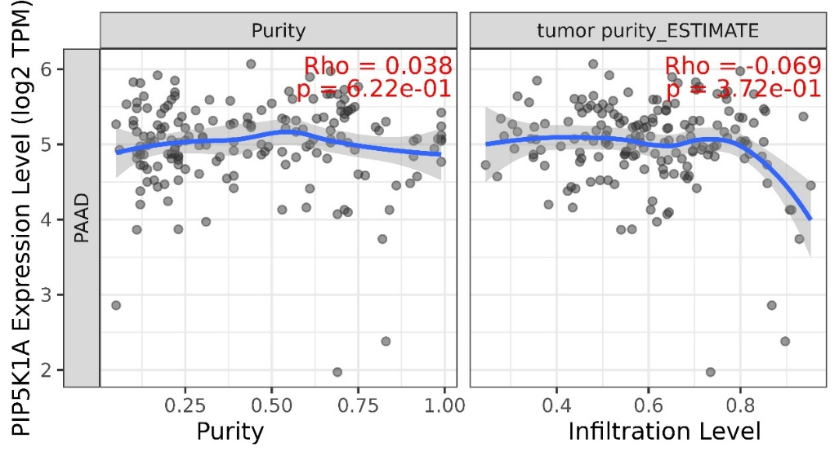

- Correlation with stroma score (not significant)
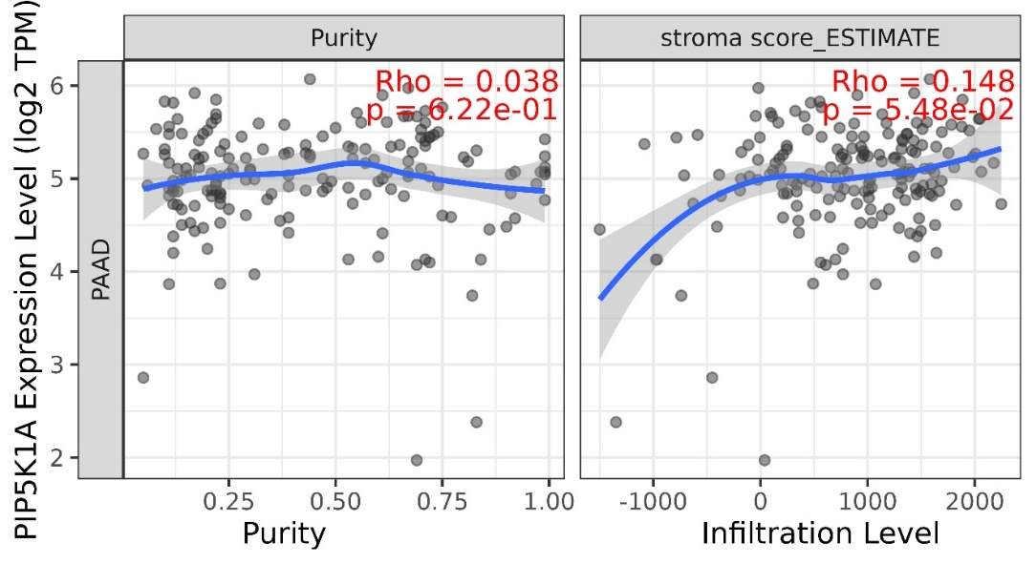
- Correlation with Immune score (not significant)
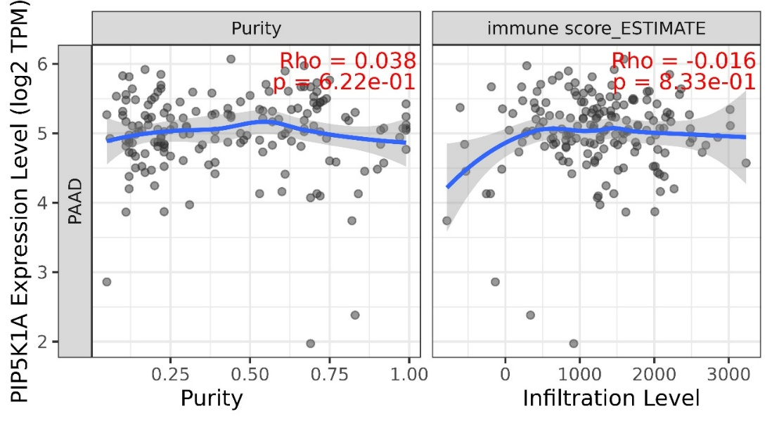
- Correlation with cancer associated fibroblasts EPIC (positive correlation)
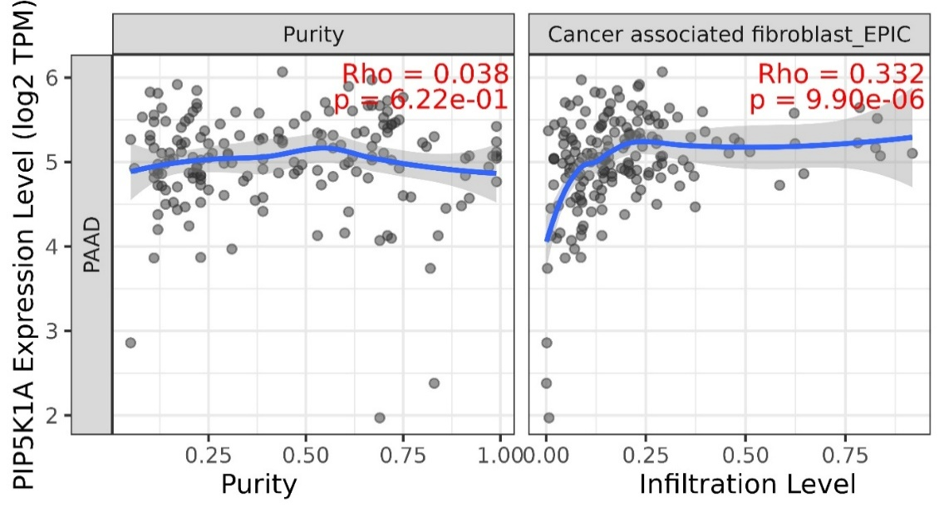
- Correlation with common myeloid progenitors (not significant)
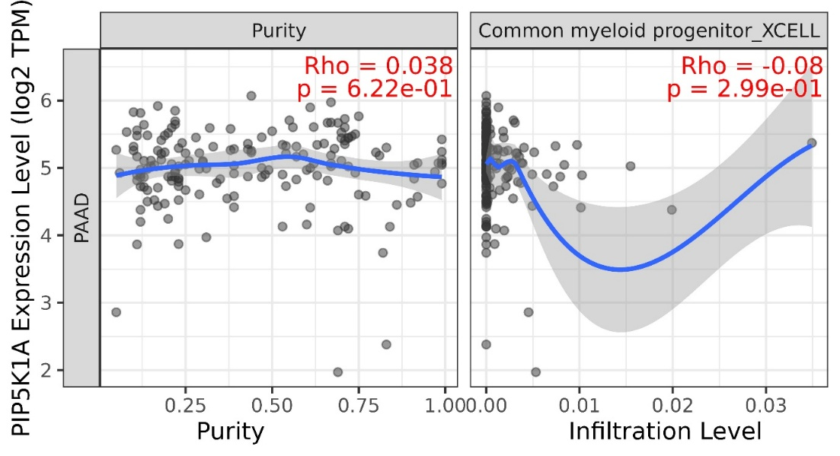
- Correlation with Endothelial cells EPIC (positive correlation)
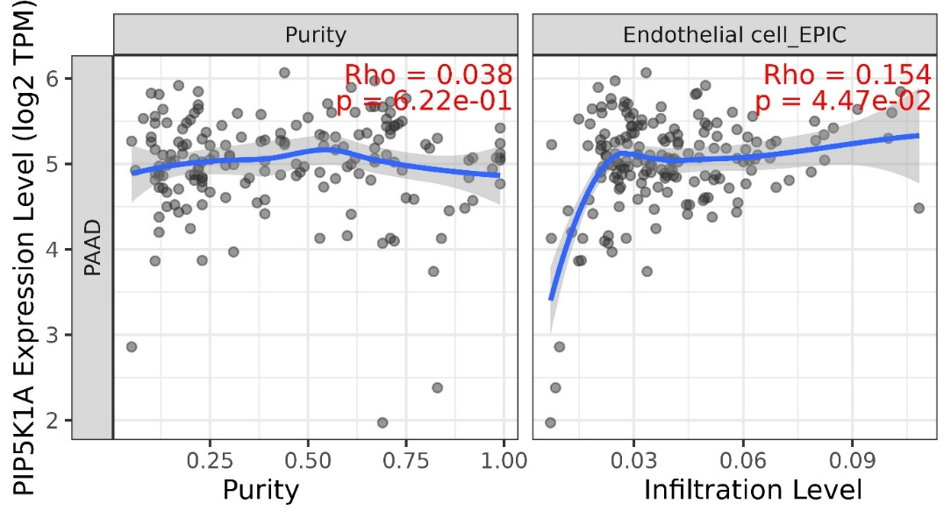
- Correlation with CD274 (positive correlation)
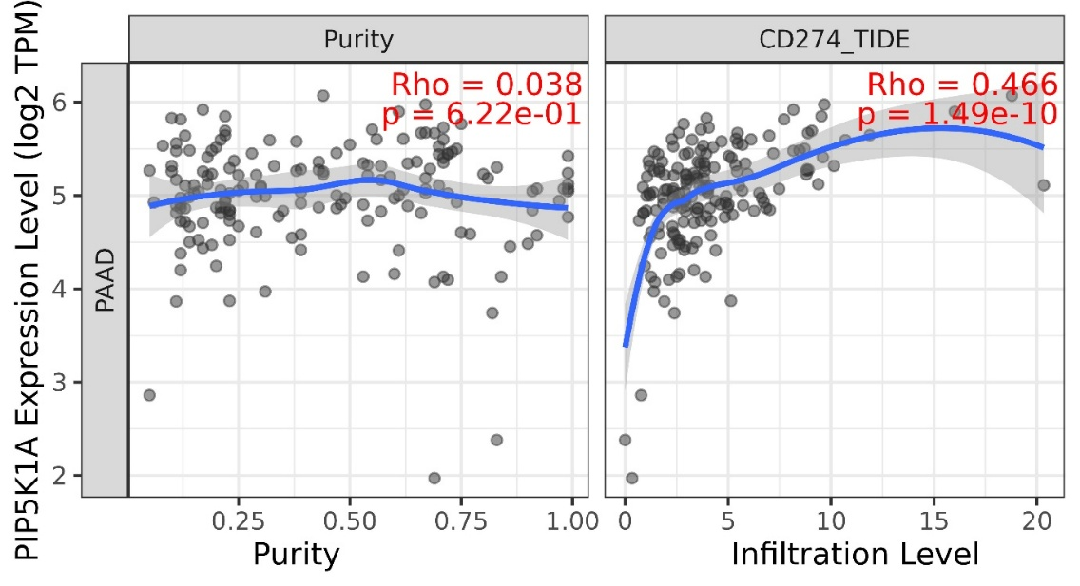
- Correlation with MDSCs (positive correlation)
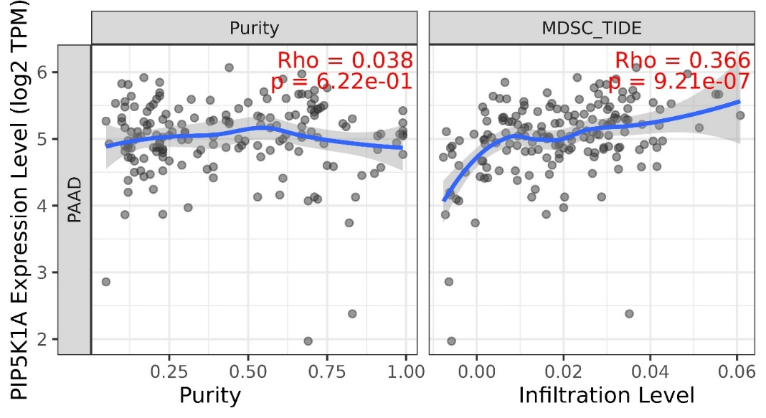
- Correlation with interferon gamma (positive correlation)
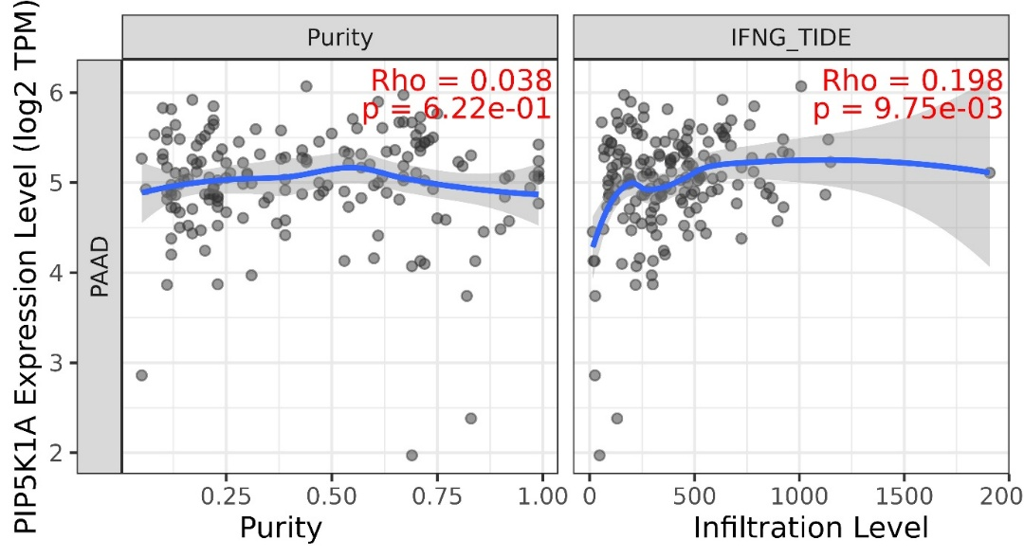
- Correlation with common lymphoid progenitors (positive correlation)
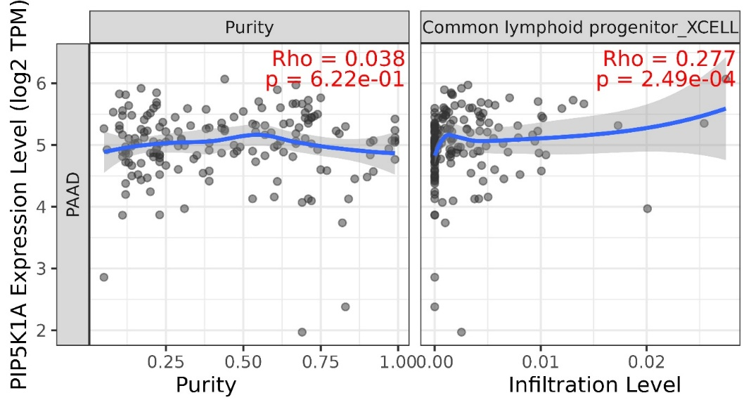

- Correlation with NK cells activated (negative correlation)
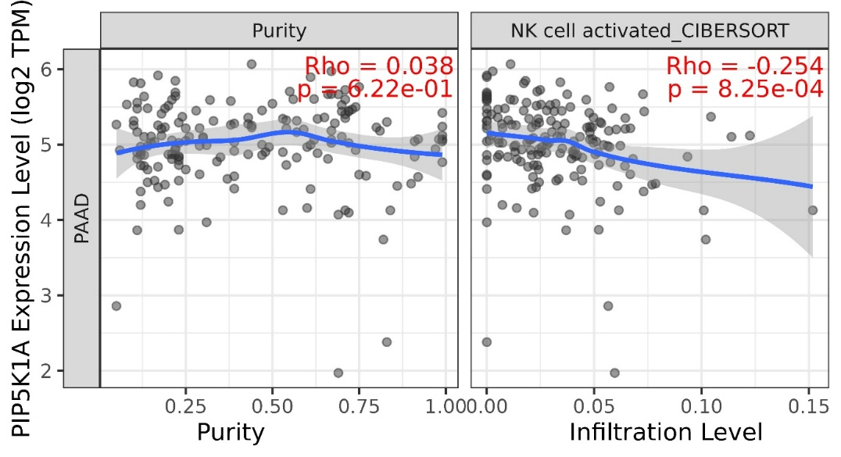

TCGA-PAAD: PIP5K1A Correlation with available 30 genes
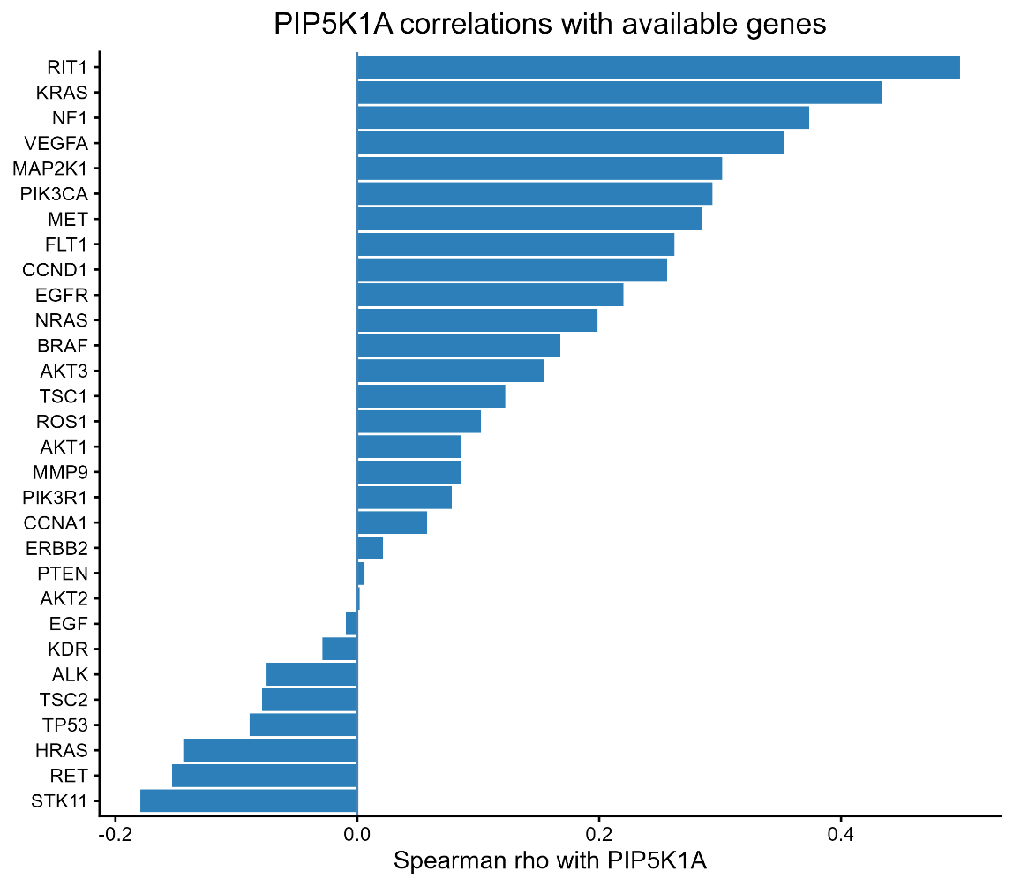
Correlation study was carried out using Spearman’s correlation test on 30 genes against PIP5K1A. The data was normalized and variance stabilizing transformation was done for validity. 8 genes showed negative correlation with PIP5K1A, while the remaining 22 genes showed positive correlation. The results were consistent with previous findings, validating them.
Summary table

Gene | Rho | P Value
RIT1 | 0.498186 | 0
KRAS | 0.433948 | 1.37E-09
NF1 | 0.373651 | 2.53E-07
VEGFA | 0.353152 | 1.19E-06
MAP2K1 | 0.30159 | 3.82E-05
PIK3CA | 0.293735 | 6.15E-05
MET | 0.285451 | 0.0001
FLT1 | 0.262419 | 0.000361
CCND1 | 0.255964 | 0.000507
EGFR | 0.220145 | 0.00288
NRAS | 0.198886 | 0.007194
STK11 | -0.17919 | 0.015605
BRAF | 0.168056 | 0.023448
AKT3 | 0.153977 | 0.038043
RET | -0.15294 | 0.039371
HRAS | -0.1441 | 0.05236
TSC1 | 0.122296 | 0.100009
ROS1 | 0.10208 | 0.170302
TP53 | -0.08927 | 0.230528
AKT1 | 0.085747 | 0.249498
MMP9 | 0.08553 | 0.250702
TSC2 | -0.07866 | 0.290869
PIK3R1 | 0.07804 | 0.294728
ALK | -0.0749 | 0.314972
CCNA1 | 0.057602 | 0.439527
KDR | -0.0289 | 0.698325
ERBB2 | 0.021286 | 0.775271
EGF | -0.00912 | 0.902792
PTEN | 0.006094 | 0.934871
AKT2 | 0.001908 | 0.979596

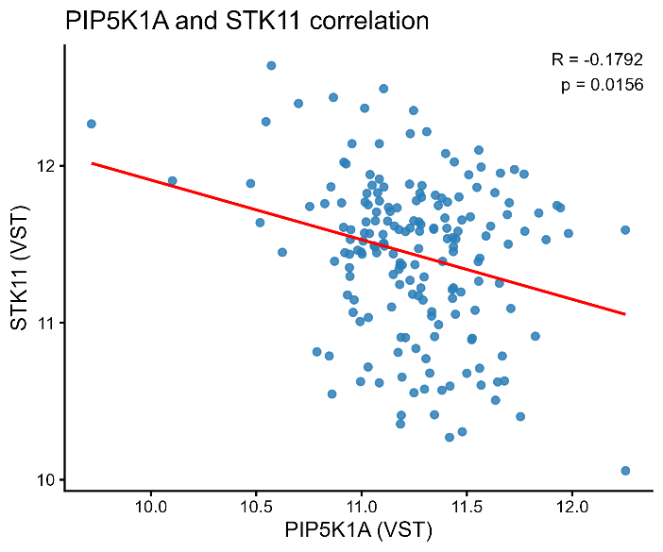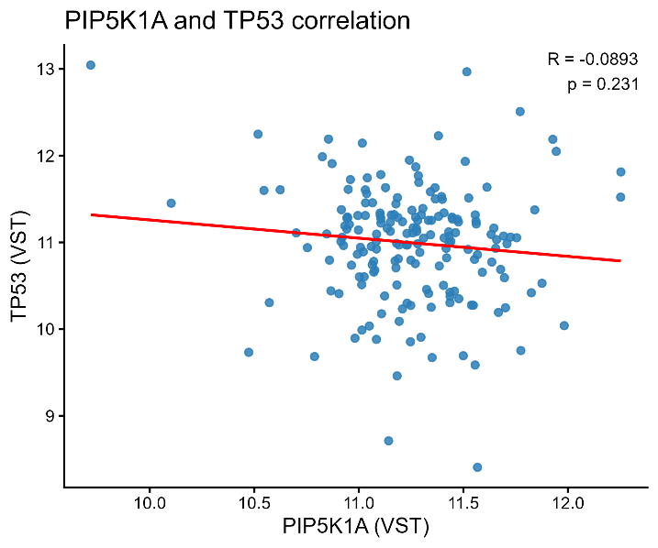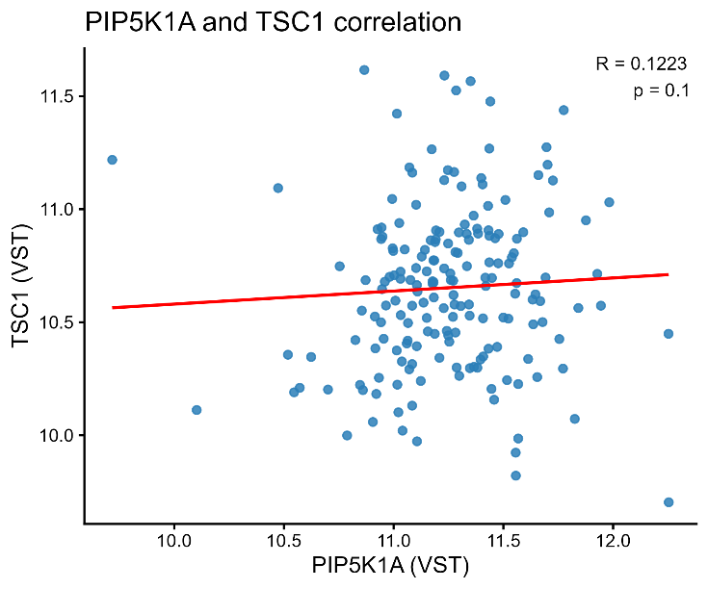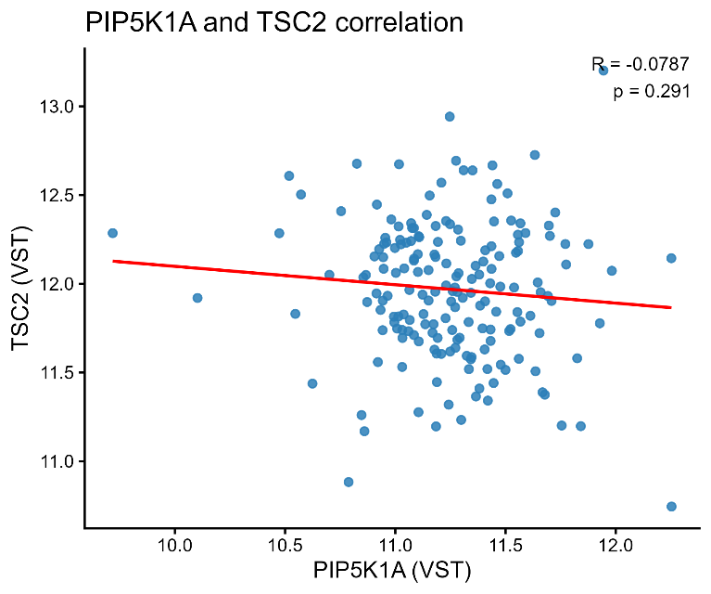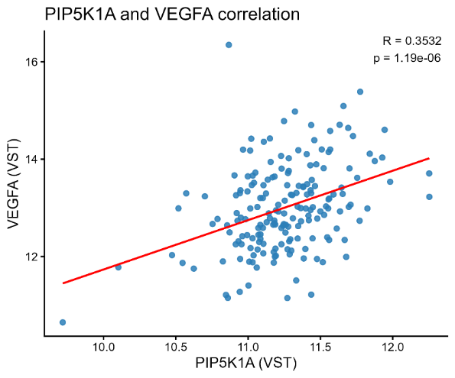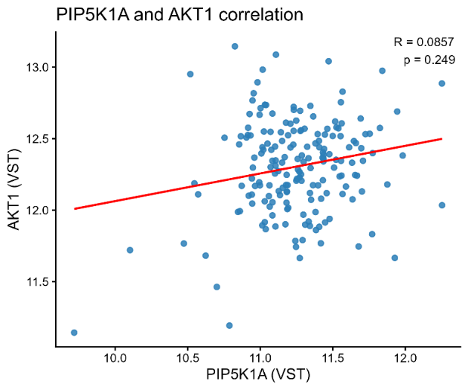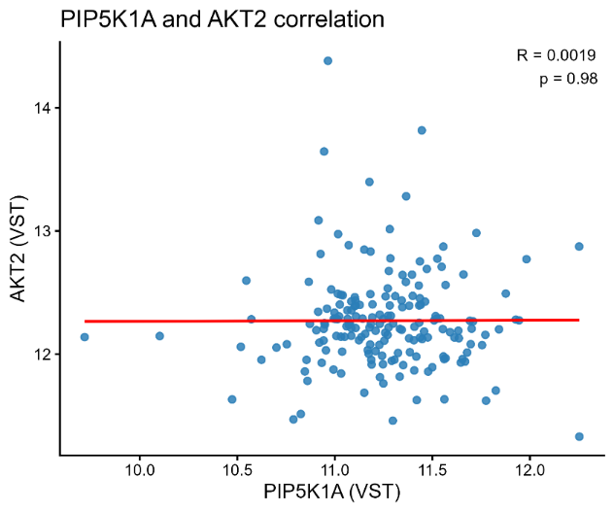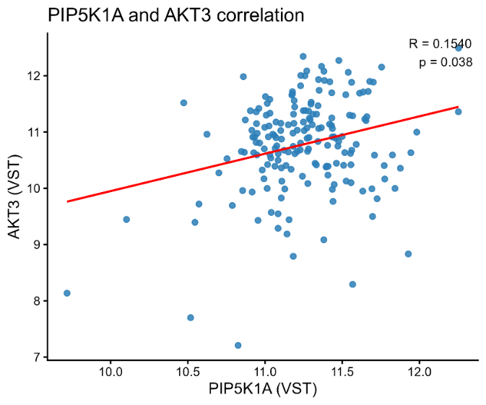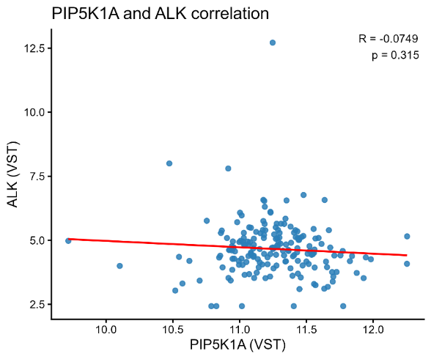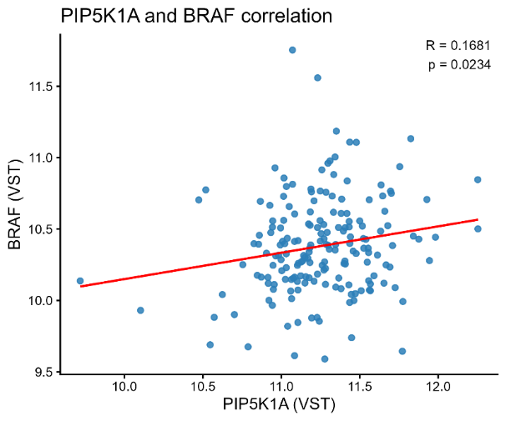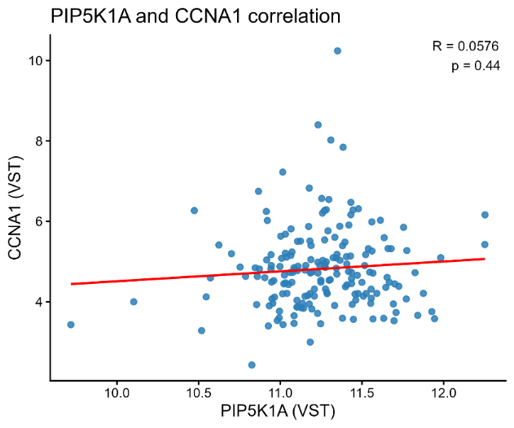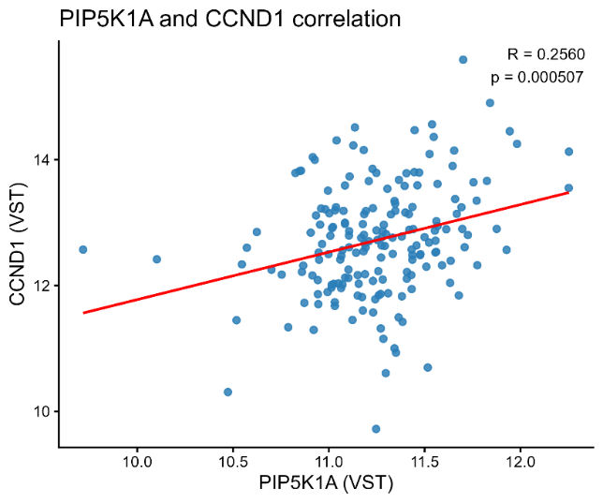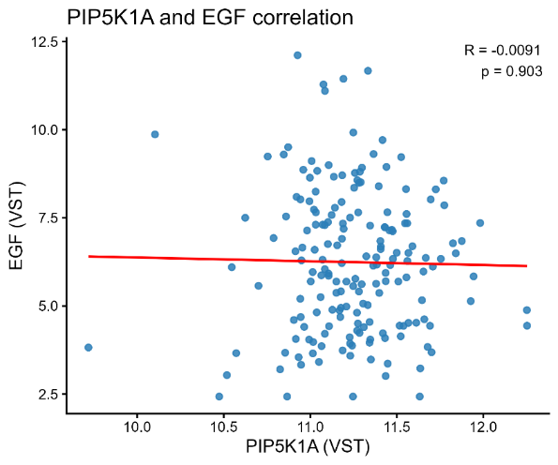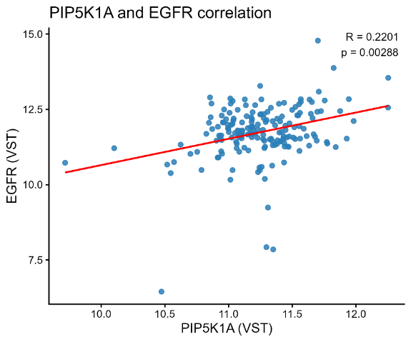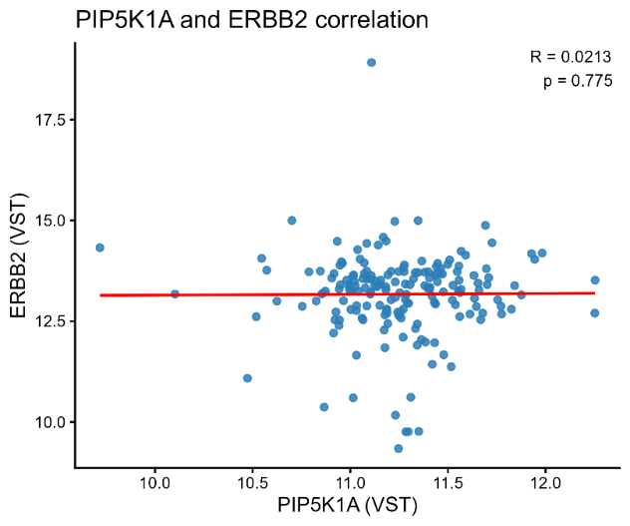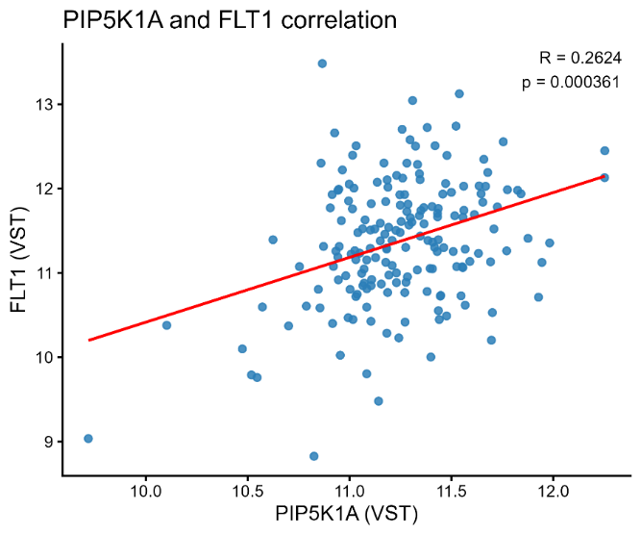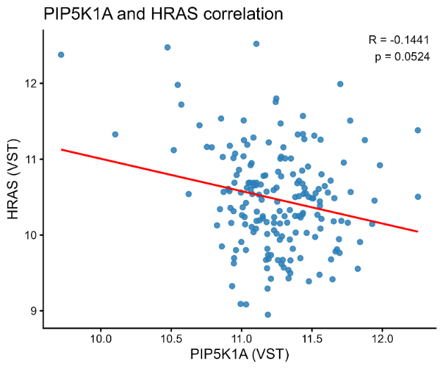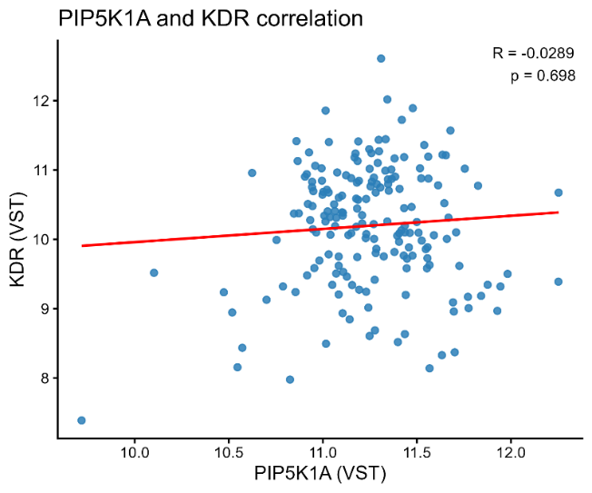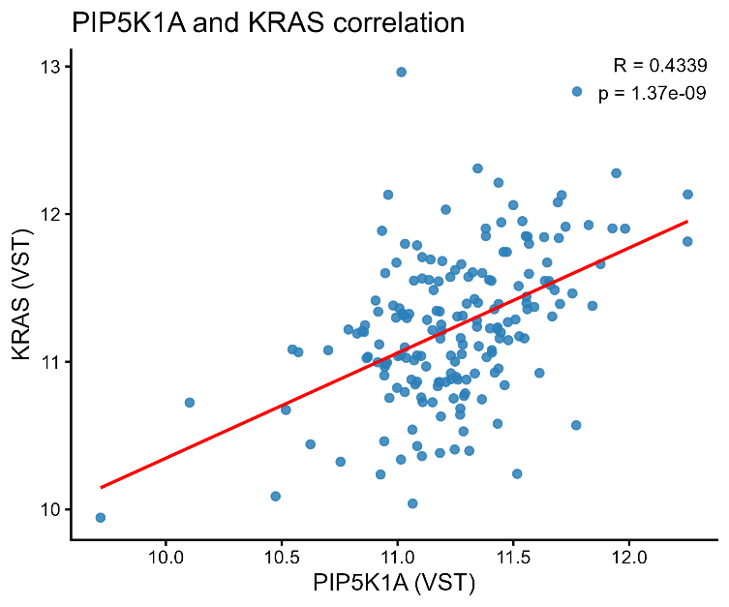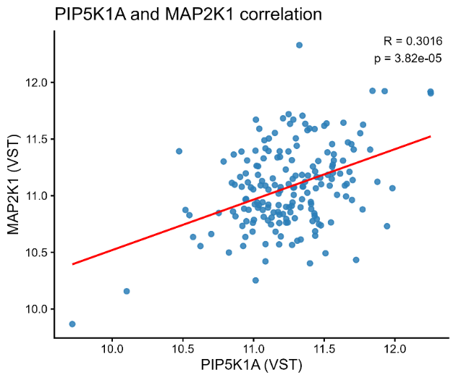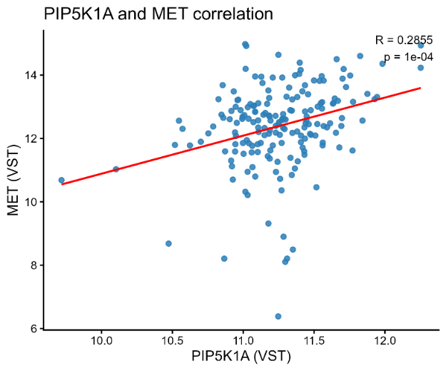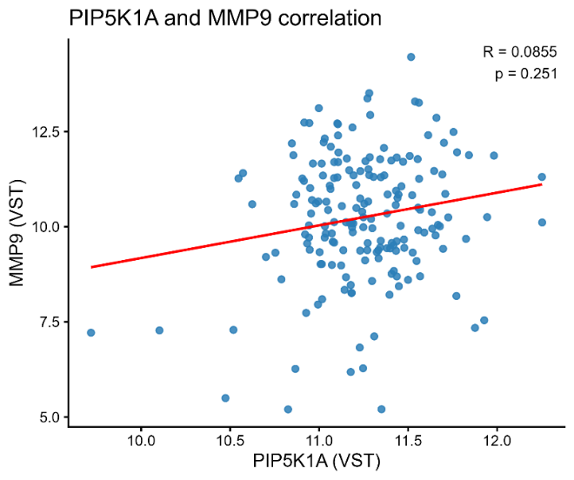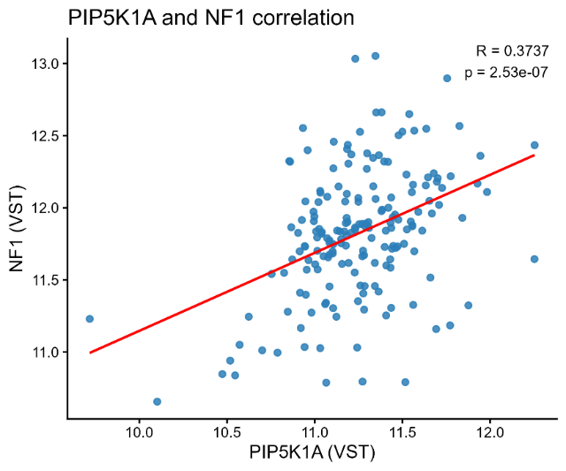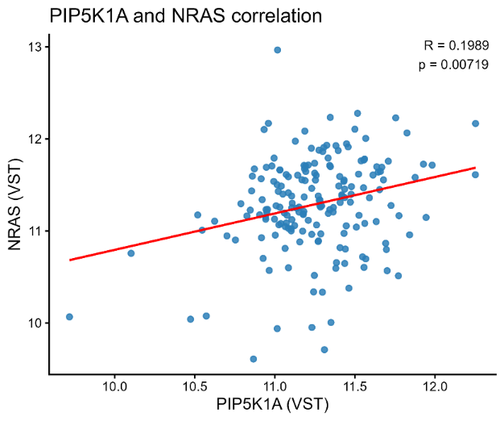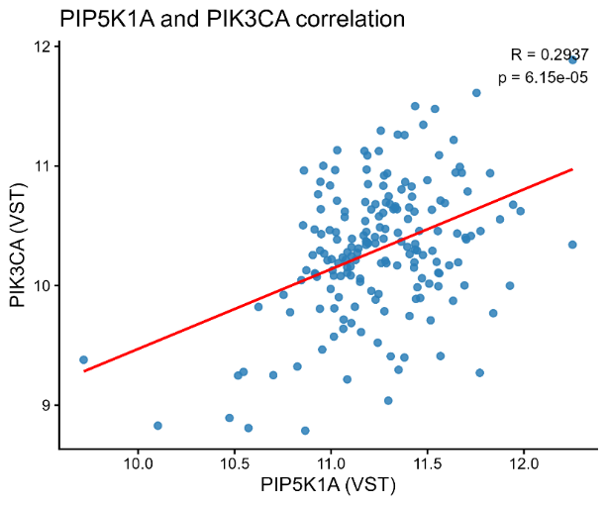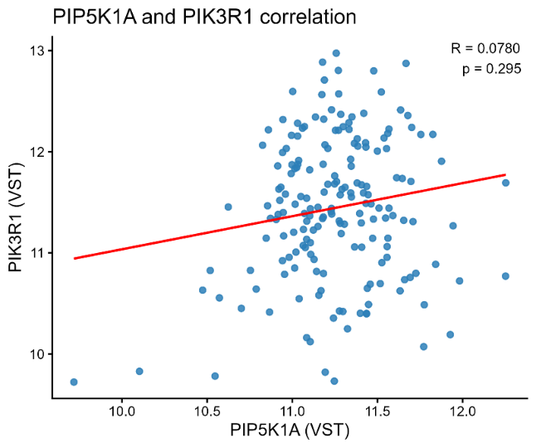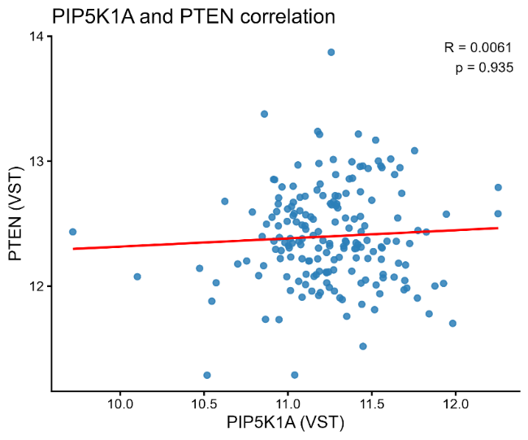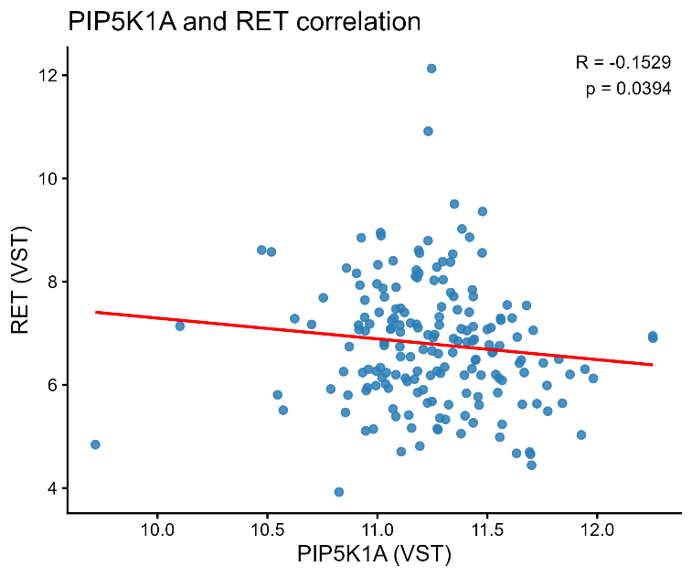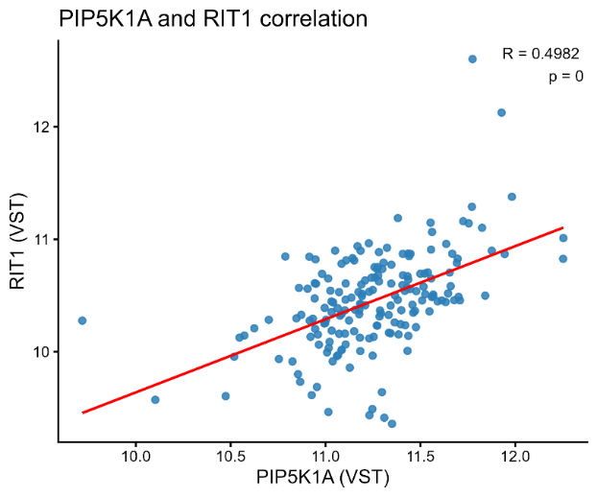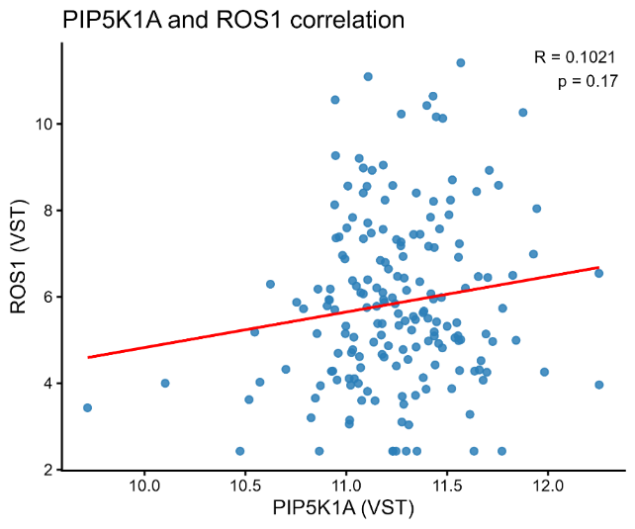

Progression Free Survival (PFS) study of PIP5KIA based on various parameters in PAAD
The analysis was attempted locally on R using TCGA data at first, but the PFS data columns as well as all other columns from which PFS could have been derived were empty (NA) in the downloadable data file. Therefore, I switched to an online tool, TIMER 3 by compbio, which was the same tool used by the original bioinformatician. KM plots for each parameter were plotted using this tool, and the corresponding Hazard ratio and p value for each can be seen on the individual graphs, as well as the summarised table below.
The two parameters in red in the table below showed increased risk (z>0) that was significant (p<0.05), while all other parameters showed non-significance.
Parameter |  | HR | p
Tumor purity | 2 vs 1 | 1.74 | 0.0853
 | 4 vs 3 | 0.761 | 0.362
Stroma score | 2 vs 1 | 0.725 | 0.315
 | 4 vs 3 | 1.21 | 0.519
Immune score | 2 vs 1 | 0.778 | 0.427
 | 4 vs 3 | 0.977 | 0.938
Cancer associated fibroblast | 2 vs 1 | 0.706 | 0.302
 | 4 vs 3 | 1-46 | 0.227
Common myeloid progenitors | 2 vs 1 | 1.05 | 0.887
 | 4 vs 3 | 0.667 | 0.227
Endothelial cells | 2 vs 1 | 0.634 | 0.165
 | 4 vs 3 | 0.748 | 0.319
Tumor CD274 | 2 vs 1 | 0.612 | 0.172
 | 4 vs 3 | 2.78 | 0.0035
Myeloid-derived suppressor cells | 2 vs 1 | 1.14 | 0.682
 | 4 vs 3 | 1.2 | 0.552
Interferon gamma | 2 vs 1 | 0.79 | 0.484
 | 4 vs 3 | 1.38 | 0.287
Common lymphoid progenitors | 2 vs 1 | 1.88 | 0.0437
 | 4 vs 3 | 1.76 | 0.0831
NK cells activated | 2 vs 1 | 1.56 | 0.165
 | 4 vs 3 | 1.31 | 0.363

- Analysis based on Tumour purity (not significant)
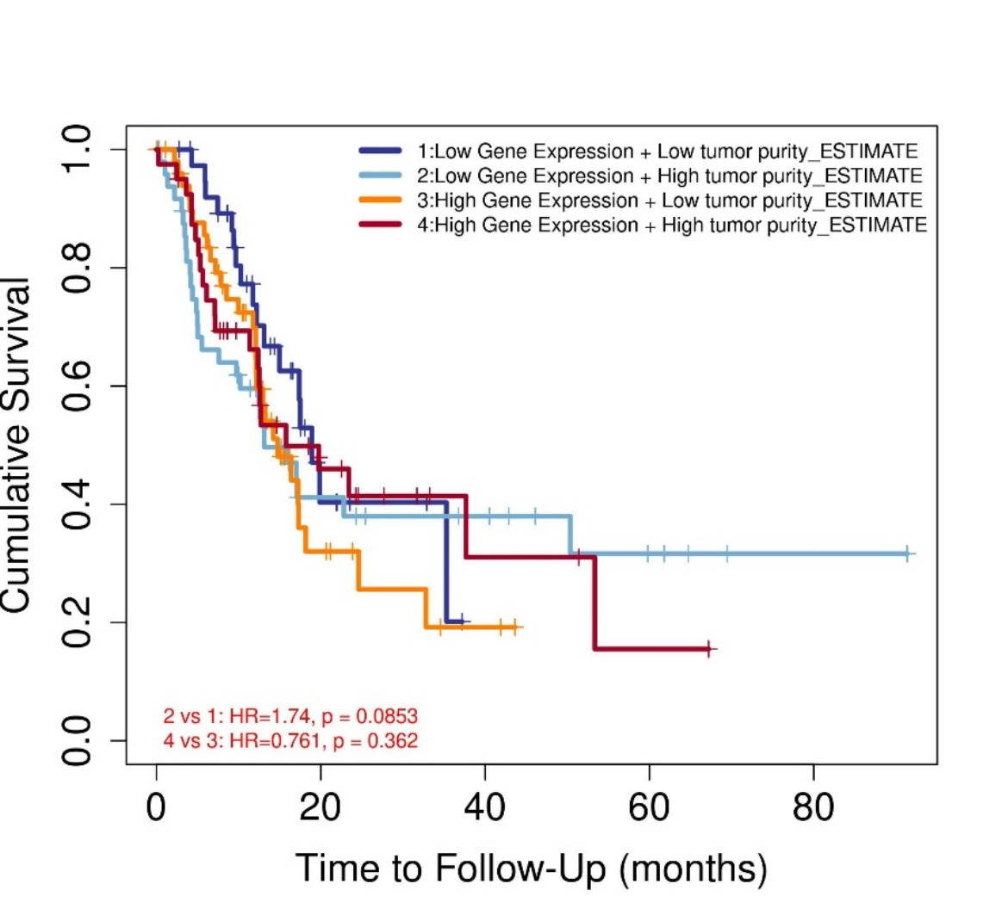
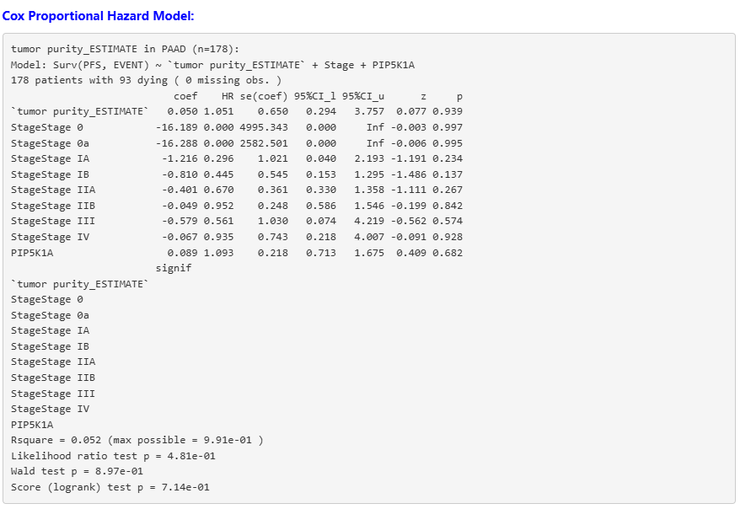
- Analysis based on Stroma Score (not significant)
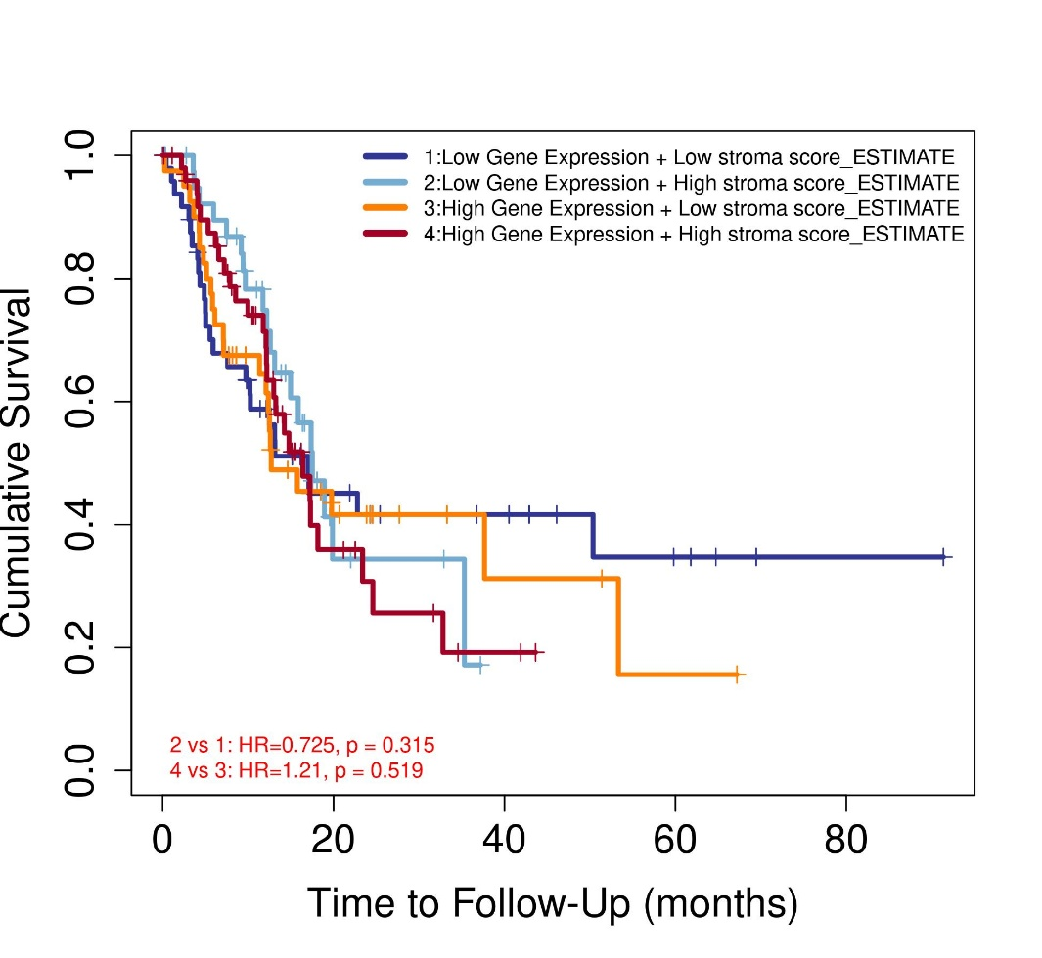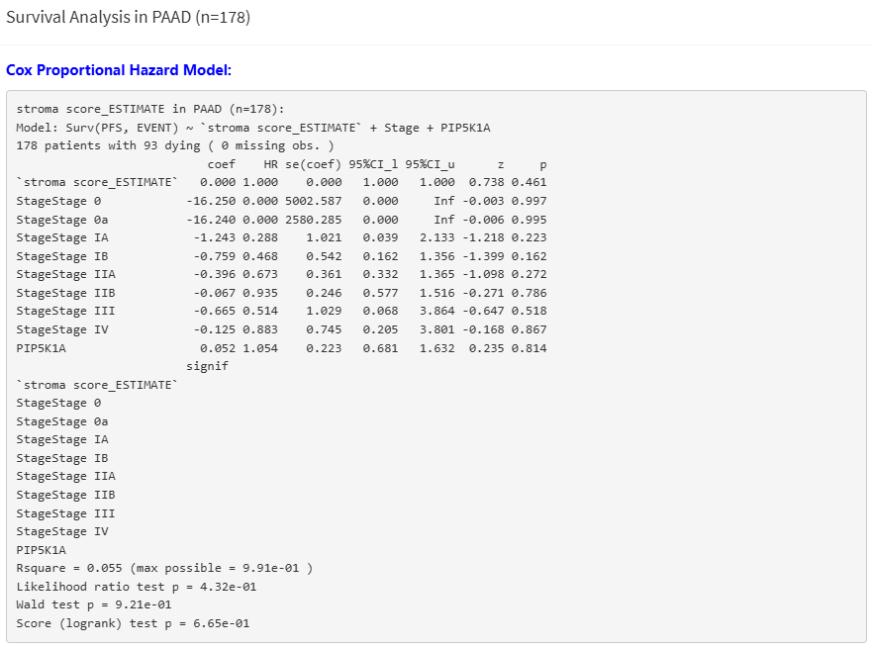
- Analysis based on Immune score (not significant)
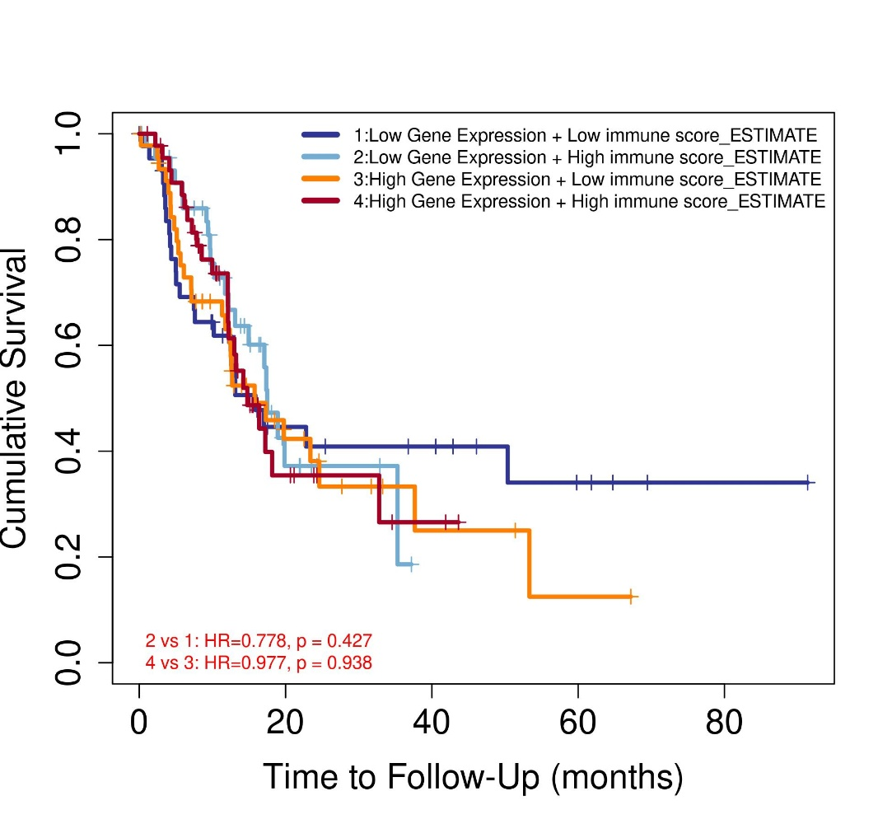
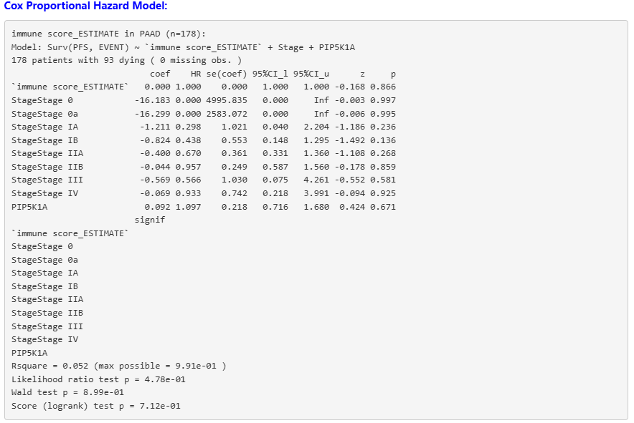

- Analysis based on Cancer associated fibroblast (EPIC) (not significant)
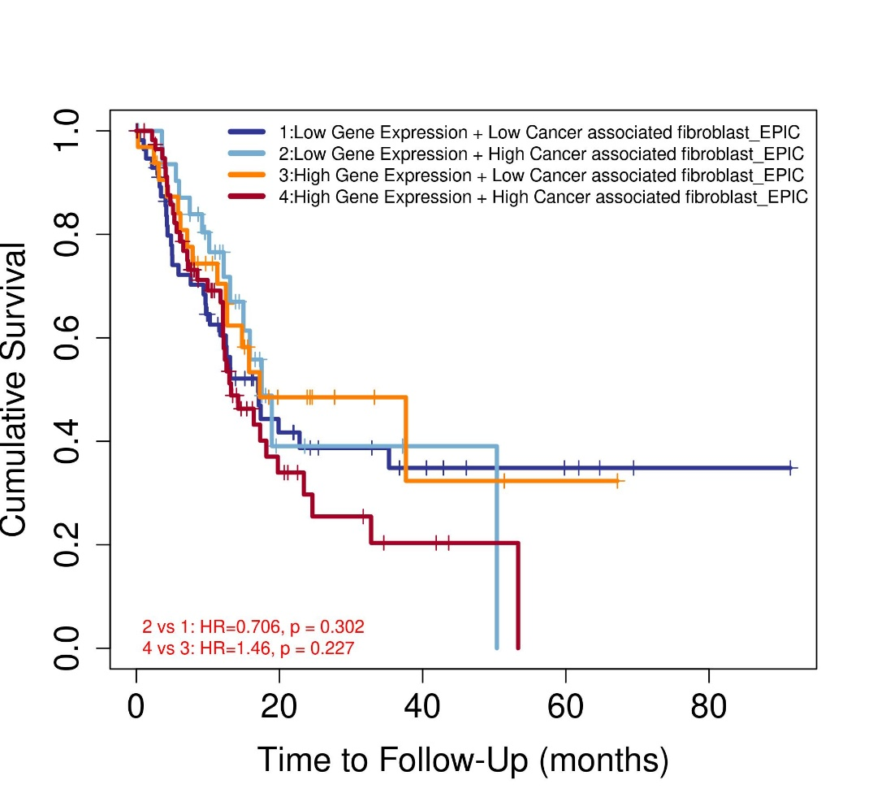
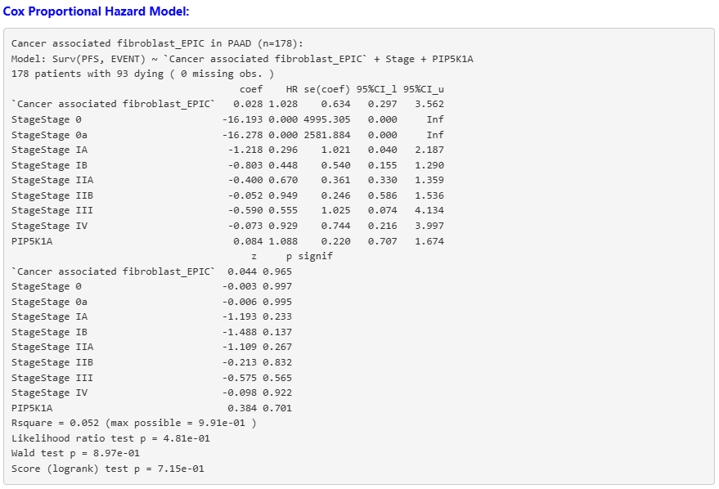

- Analysis based on Common Myeloid Progenitors (not significant)
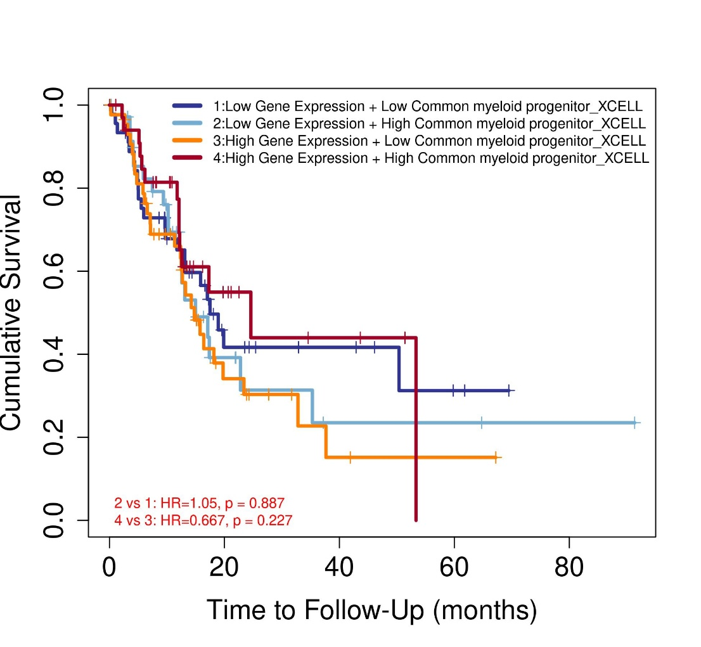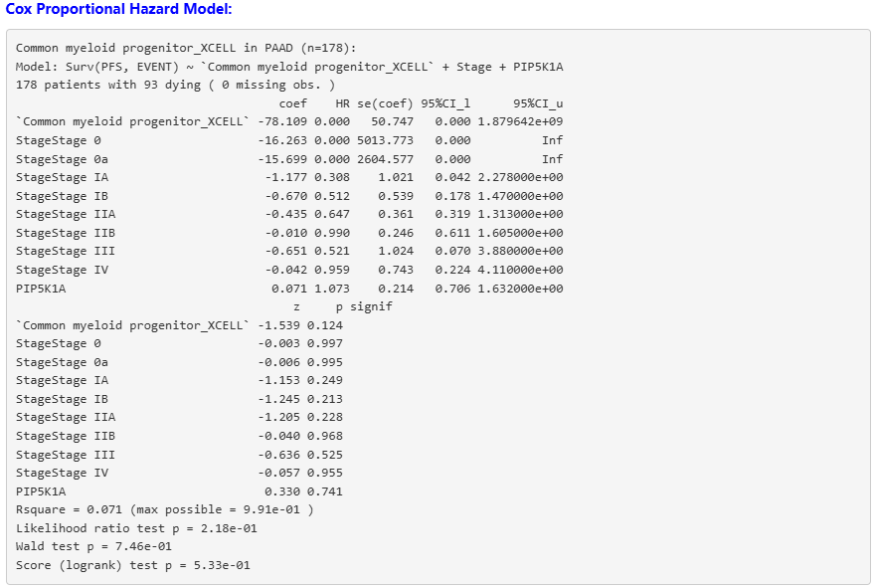

- Analysis Based on Endothelial Cells (EPIC) (not significant)
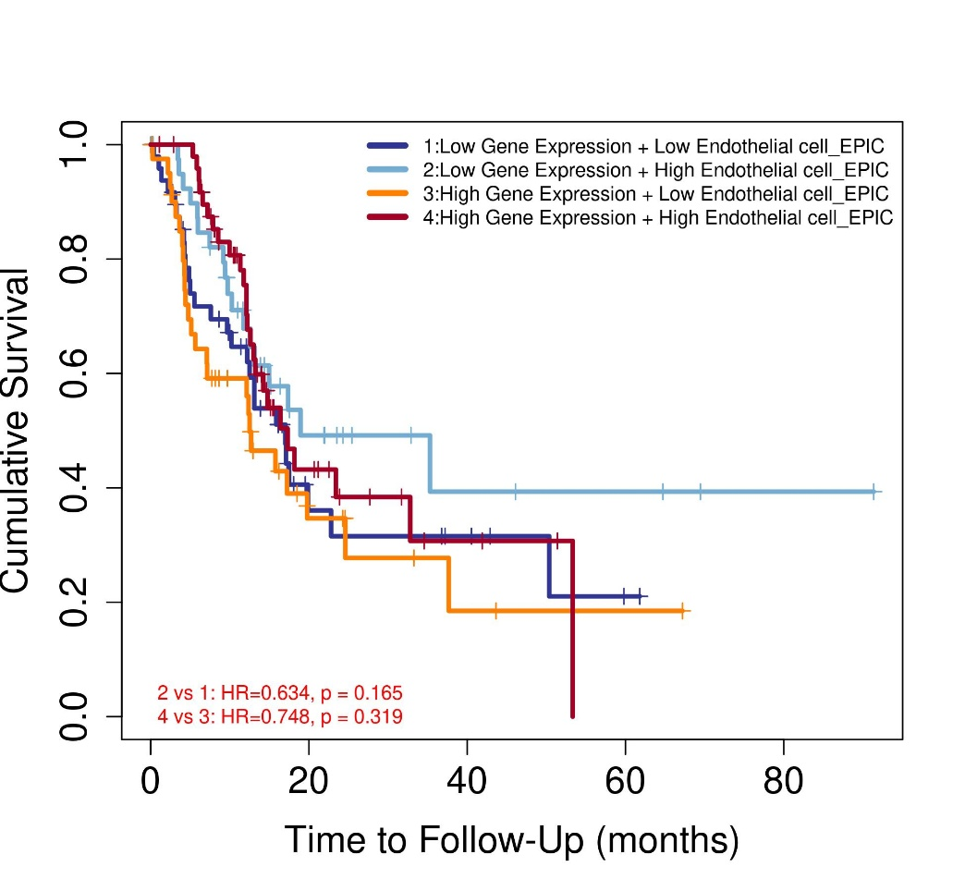
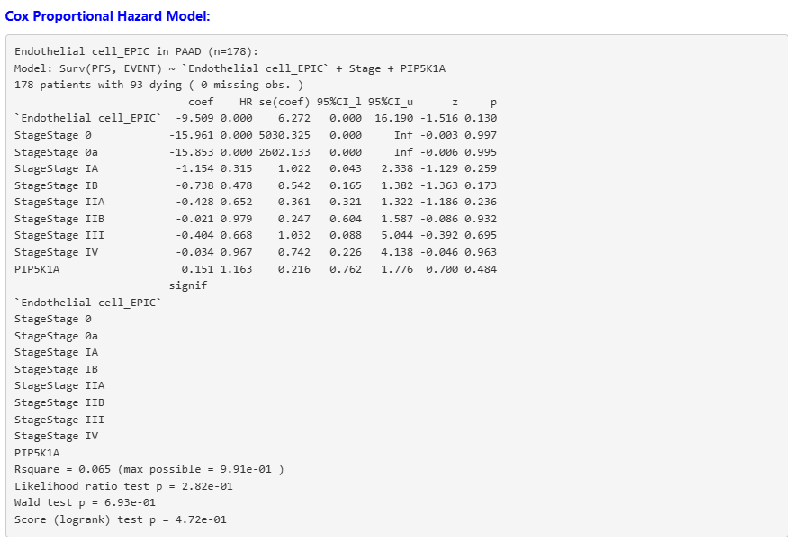
- Analysis based on Tumour CD274 (increased risk)
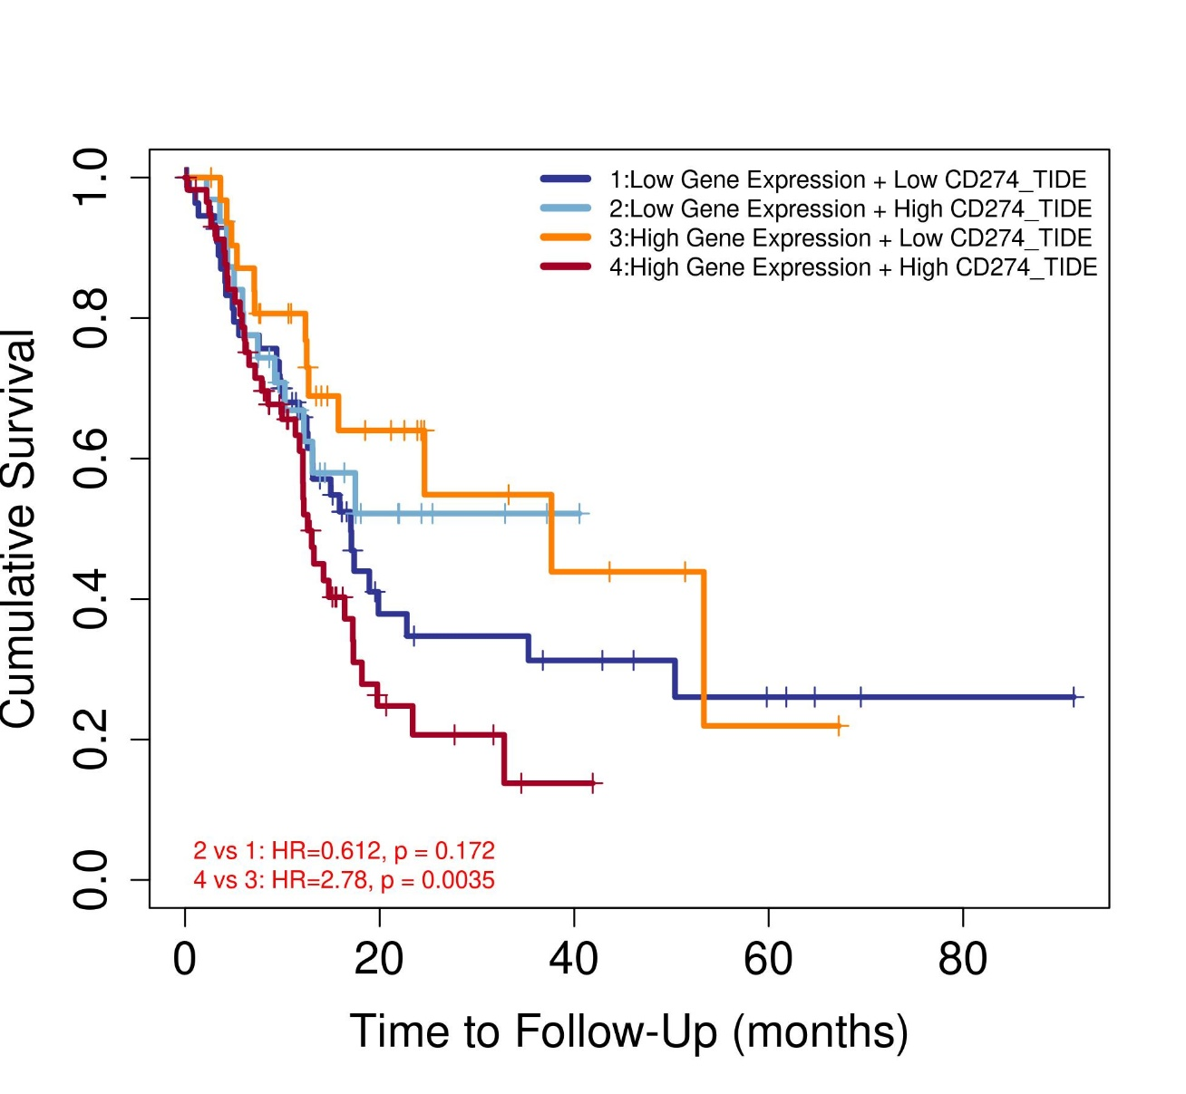
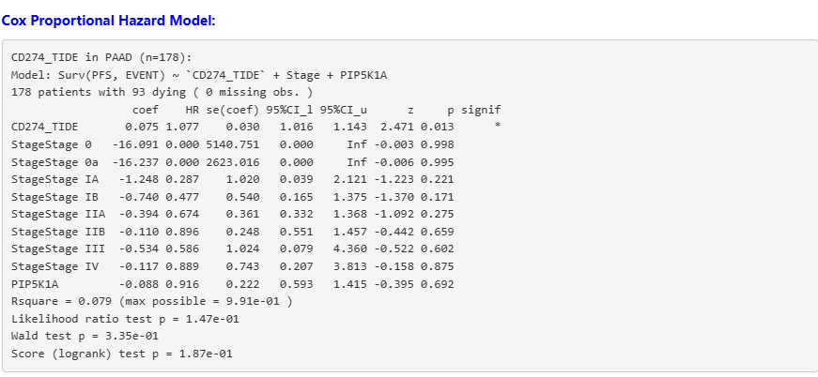

- Analysis based on Myeloid derived suppressor cells (Not significant)
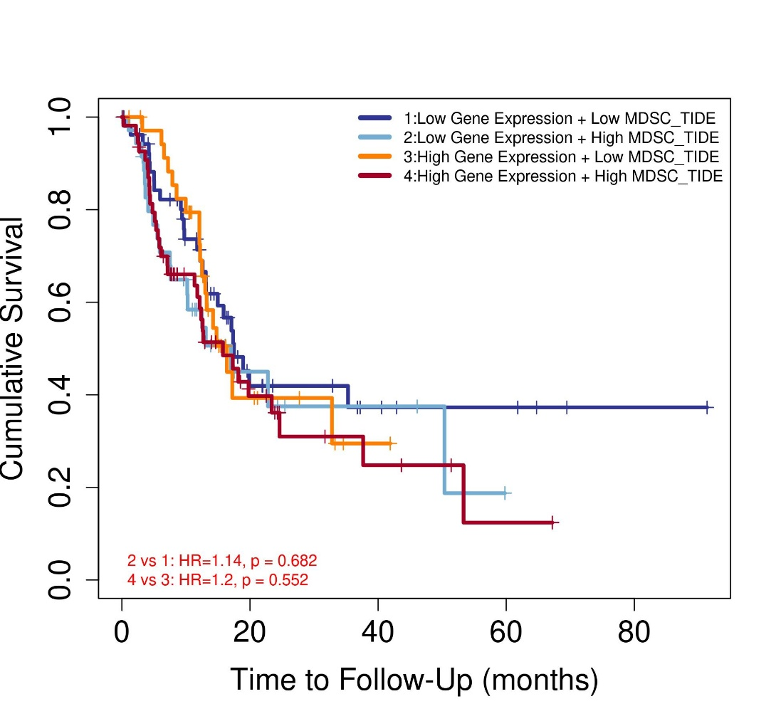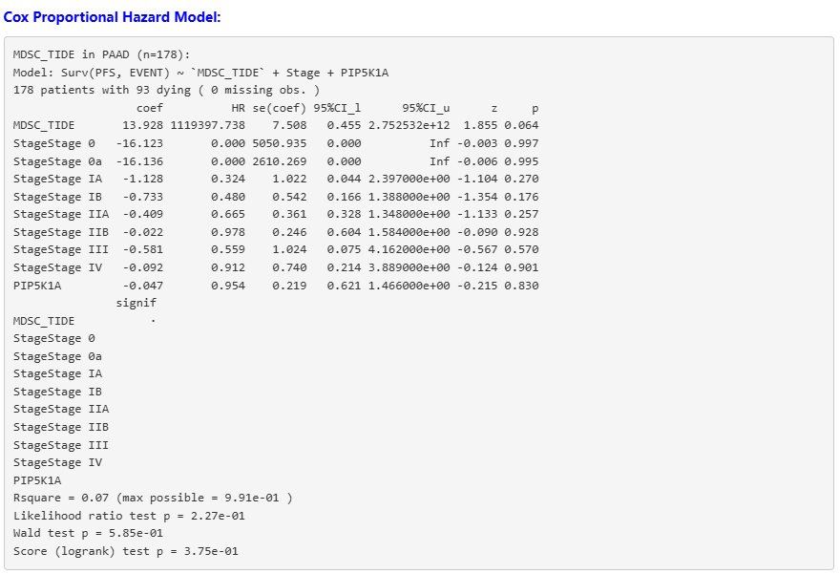
- Analysis based on inferno gamma (not significant)
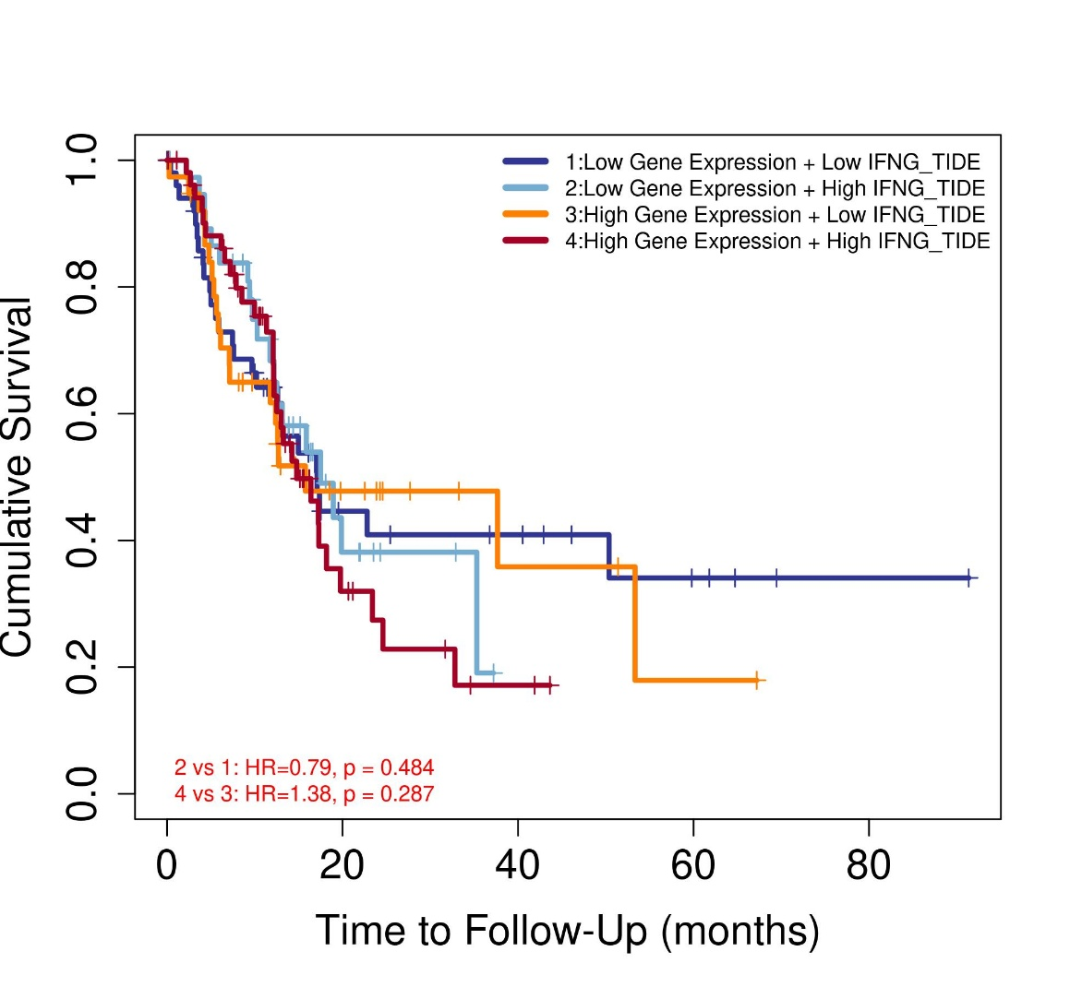
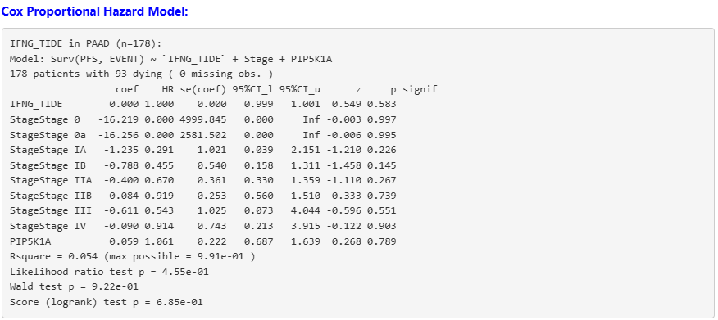

- Analysis Based on common lymphoid progenitors (Increased risk)
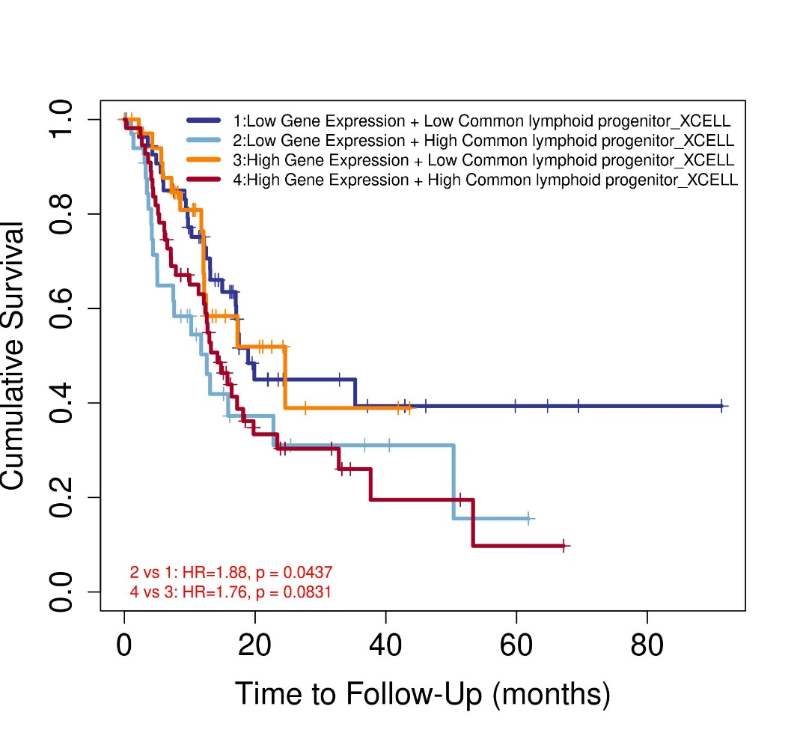
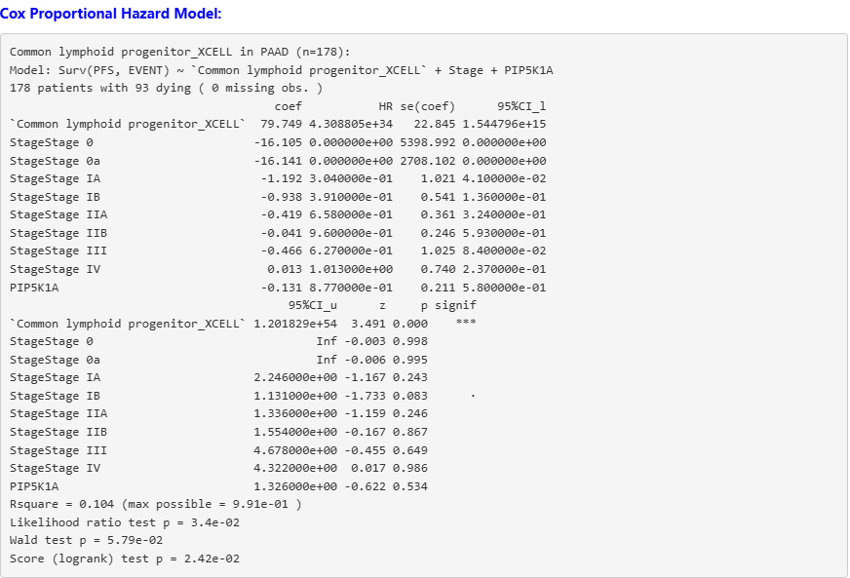

- Analysis based on NK cell activated (not significant)
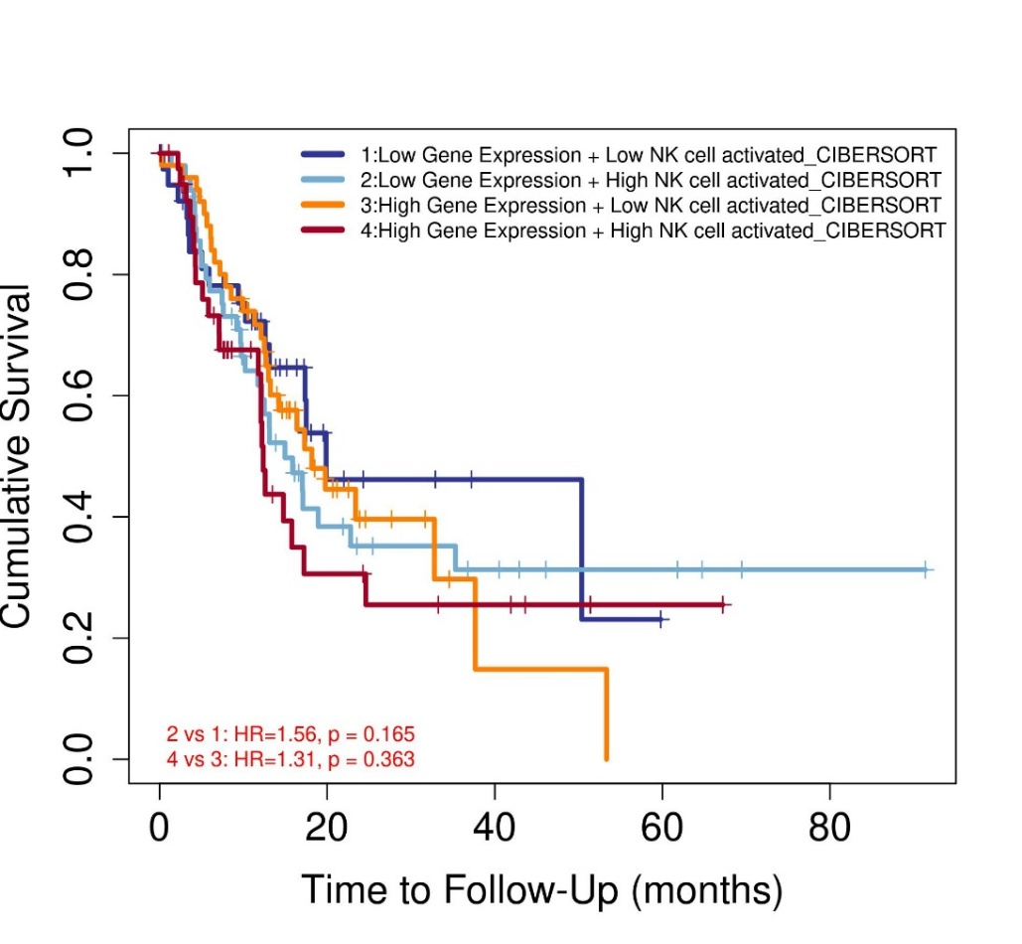
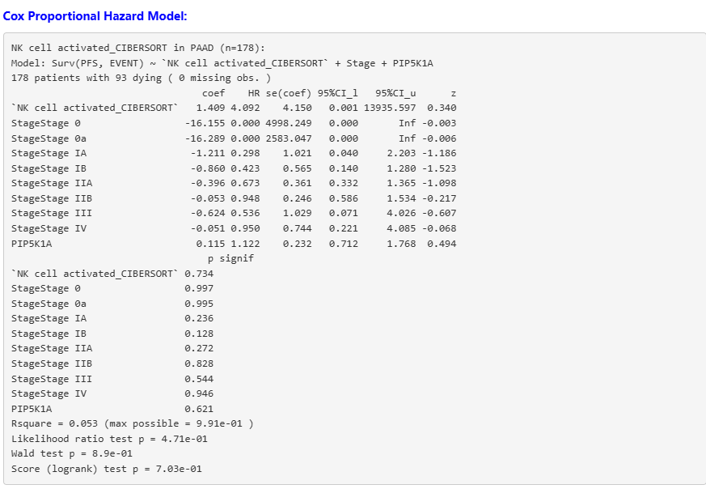

Comparison of FOLH1 with Known Biomarkers of Prostate cancer in TCG-PAAD cohort (primary tumour)
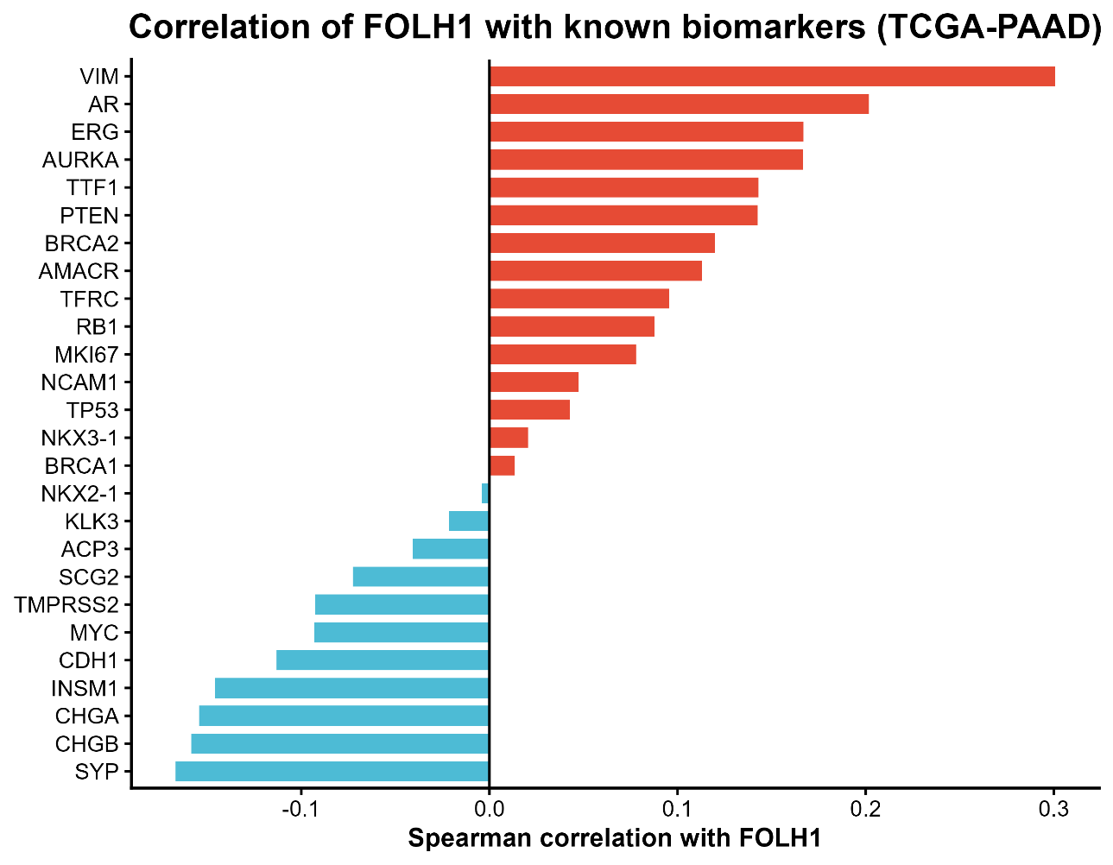
Spearman correlation on the VST expression of each of these biomarkers with FOLH1 expression was carried out, and the resulting bar plot generated is seen above. New biomarkers mentioned by Felecia during our meeting were also included. The data shows interesting differences with the Prostate cancer analysis.
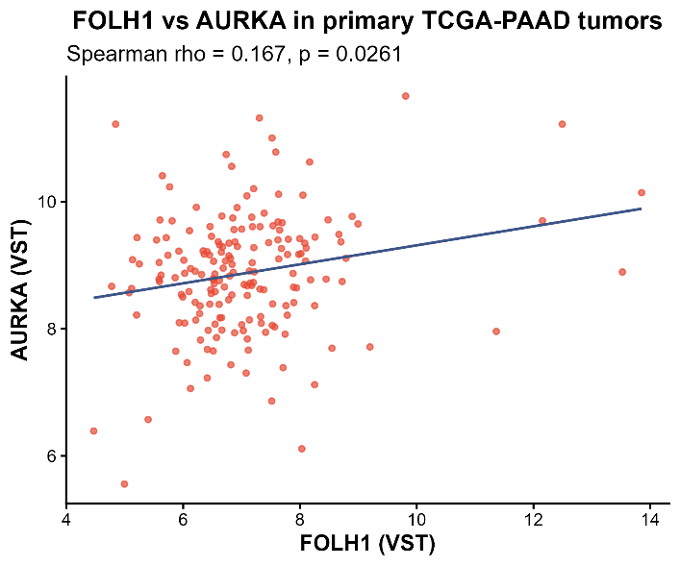
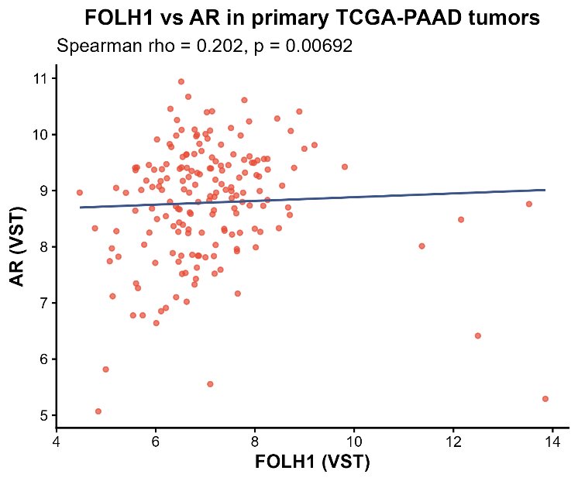
The biomarkers scatter plots for those that showed a significant correlation can be seen below.
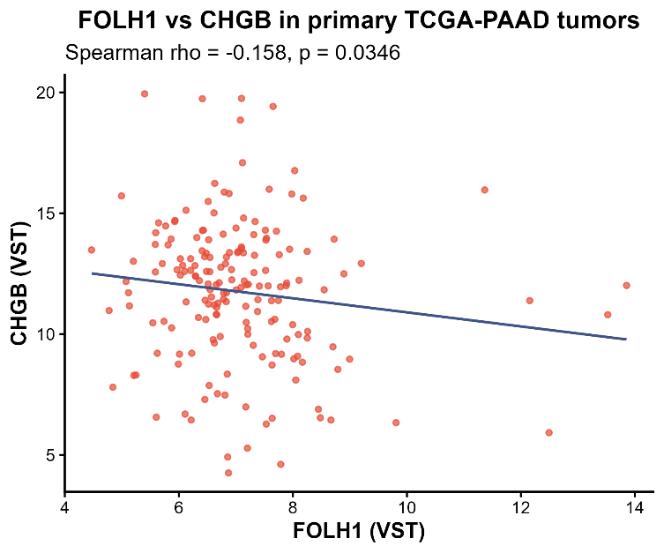
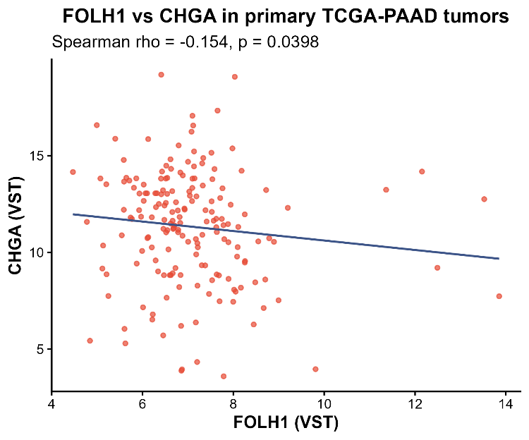
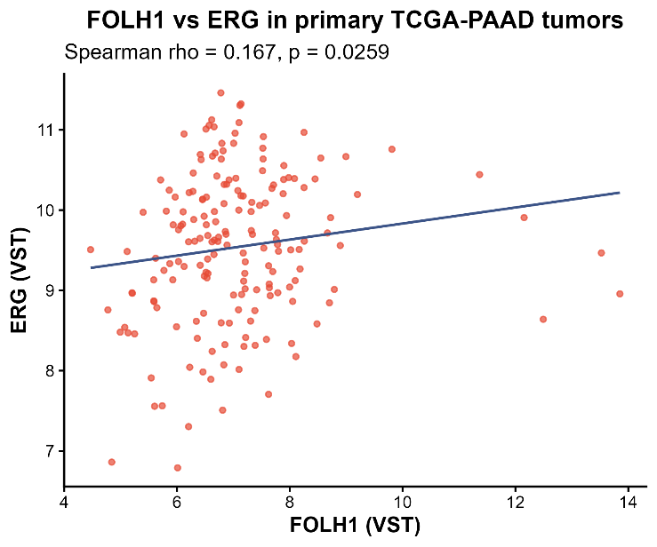
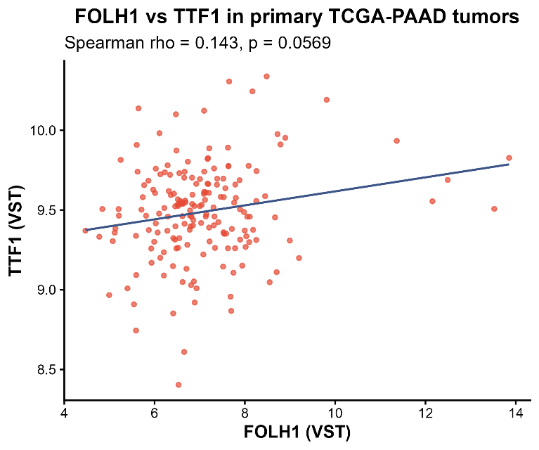
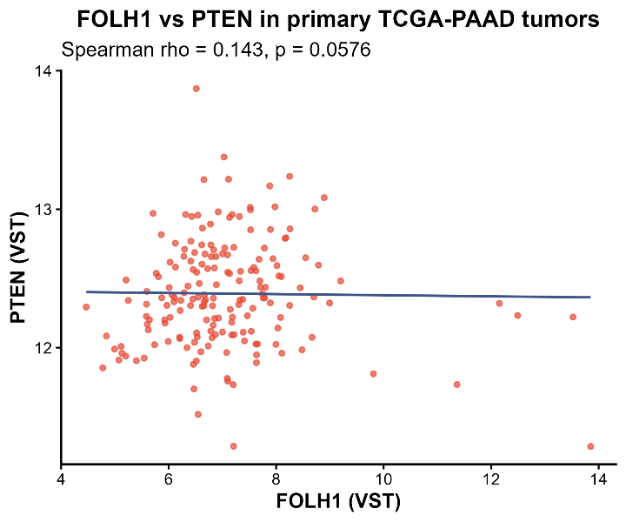
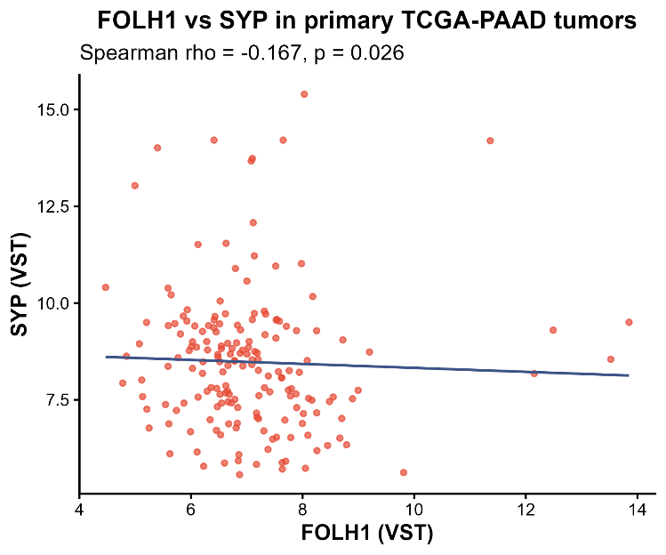
The table below summarises the statistical testing done on the correlation of each biomarker, including the p value and adjusted p value. The biomarkers highlighted in Yellow are ones recommended by Felicia M.
Gene |  | Rho value | P value | Adjusted p value
VIM |  | 0.300783 | 4.51E-05 | 0.000609
AR |  | 0.201763 | 0.006919 | 0.06227
ERG |  | 0.166971 | 0.025905 | 0.117603
AURKA |  | 0.166718 | 0.026134 | 0.117603
TTF1 |  | 0.14301 | 0.056865 | 0.141371
PTEN |  | 0.142595 | 0.057596 | 0.141371
BRCA2 |  | 0.119776 | 0.111274 | 0.250367
AMACR |  | 0.11301 | 0.133115 | 0.256722
TFRC | CD71 | 0.095525 | 0.204659 | 0.346014
RB1 |  | 0.087778 | 0.243977 | 0.365966
MKI67 |  | 0.077832 | 0.30176 | 0.428817
NCAM1 | CD56 | 0.047371 | 0.530068 | 0.681516
TP53 |  | 0.042632 | 0.572053 | 0.690757
NKX3-1 |  | 0.020598 | 0.784923 | 0.847717
BRCA1 |  | 0.013453 | 0.858542 | 0.891563
NKX2-1 |  | -0.00409 | 0.956802 | 0.956802
KLK3 |  | -0.02152 | 0.775575 | 0.847717
ACP3 | PAP | -0.04083 | 0.588422 | 0.690757
SCG2 | Synaptogranin II | -0.0725 | 0.33616 | 0.453816
TMPRSS2 |  | -0.09281 | 0.217861 | 0.346014
MYC |  | -0.09329 | 0.215517 | 0.346014
CDH1 |  | -0.11309 | 0.132851 | 0.256722
INSM1 |  | -0.14584 | 0.05208 | 0.141371
CHGA | Chromogranin A | -0.15429 | 0.039753 | 0.134167
CHGB | Chromogranin B | -0.15849 | 0.034606 | 0.133482
SYP | Synaptophysin | -0.1669 | 0.025966 | 0.117603

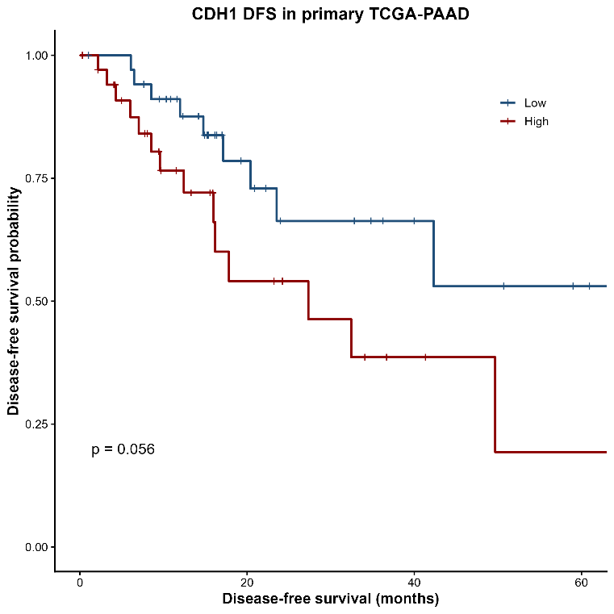
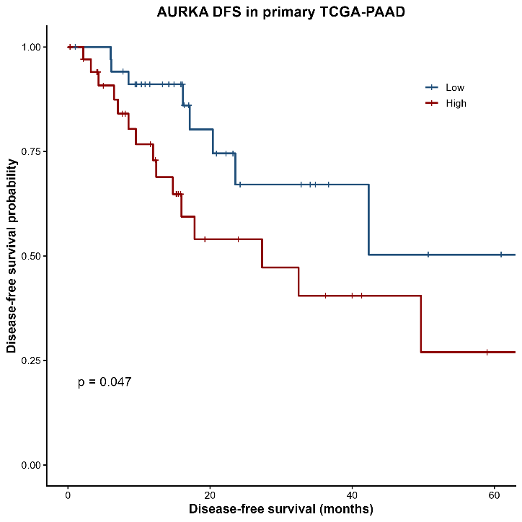
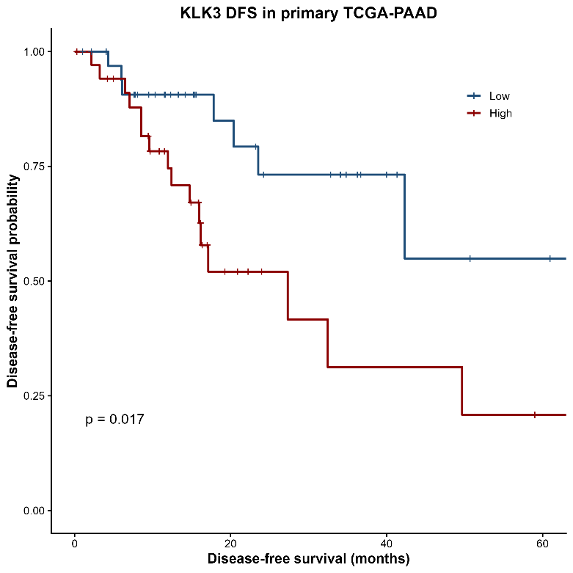
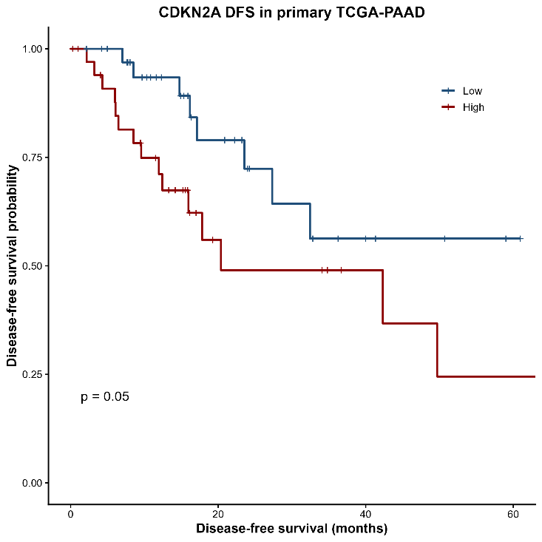
DFS Survival analysis was then carried out on each of these biomarkers, with the median expression level being used as the cut-off value for the high and low expression groups. The KM plots that also produced a significant P value are included below.

